WEEK-1
a.Create a Web Page using HTML which contains a Heading, Image and 2 hyperlinks. Each hyperlink opens a new page in the same web browser. New page contains “Go Back” link that takes you to the main page.
Week-1.html
<html>
<head>
<title>
FULL STACK DEVELOPMENT LAB/WEEK-1
</title>
</head>
<body>
<h1><img src="E:\HtmlPrograms\logo.png" width="150px" height="150px"/>
Vidya Jyothi Institute of Technology</h1>
<a target="_self" href="Welcome.html" >REGISTRATION PAGE</a><br><br><br>
<a target="_self" href="Lform.html" >Login</a>

</body>
</html>
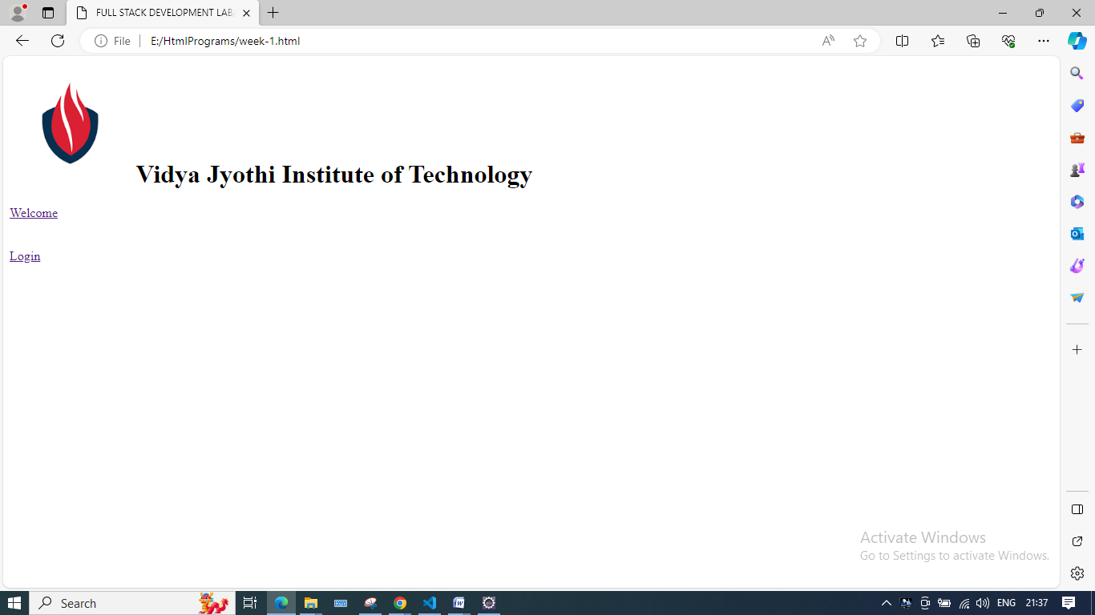

LForm.html
<html>
<head><title>login</title></head>
<body>
<form name="frm1">
<table align="center">
<caption><h3>Login</h3></caption>
<tr>
<td>UserName :</td>
<td><input type="text" name="uname"></input></td>
</tr>
<tr>
<td>Password :</td>
<td><input type="password" name="pwd"></input></td>
</tr>
<tr><td></td>
<td><input type="button" name="login" value="Login"></input></td>&nbsp;
<td><a href="week-1.html"><input type="button" name="GOBAck" value="GoBack"/></a></td>
</tr>
</table>
</form>
</body>
</html>

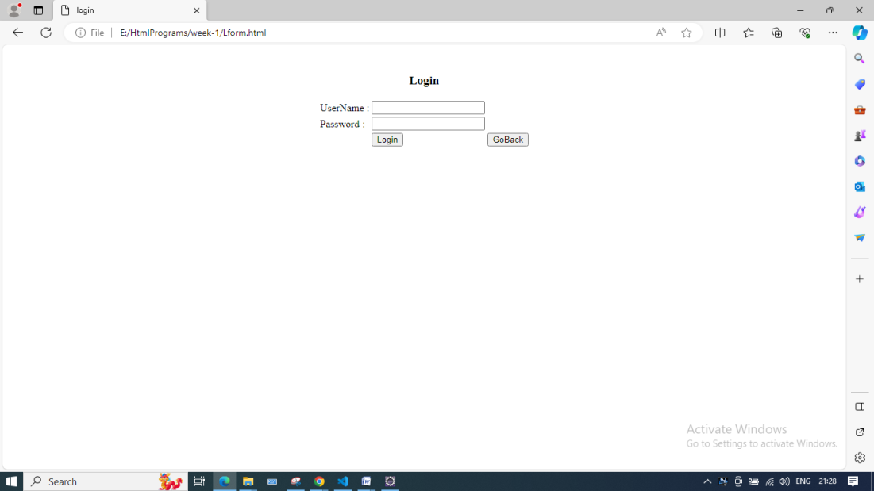
Welcome.html
<html>
<head>
<title>Welcome</title>
</head>
<body>
Welcome to VJIT<br><br><br>
<a href="week-1.html"><input type="button" name="GOBAck" value="GoBack"/></a>
</body>
</html>

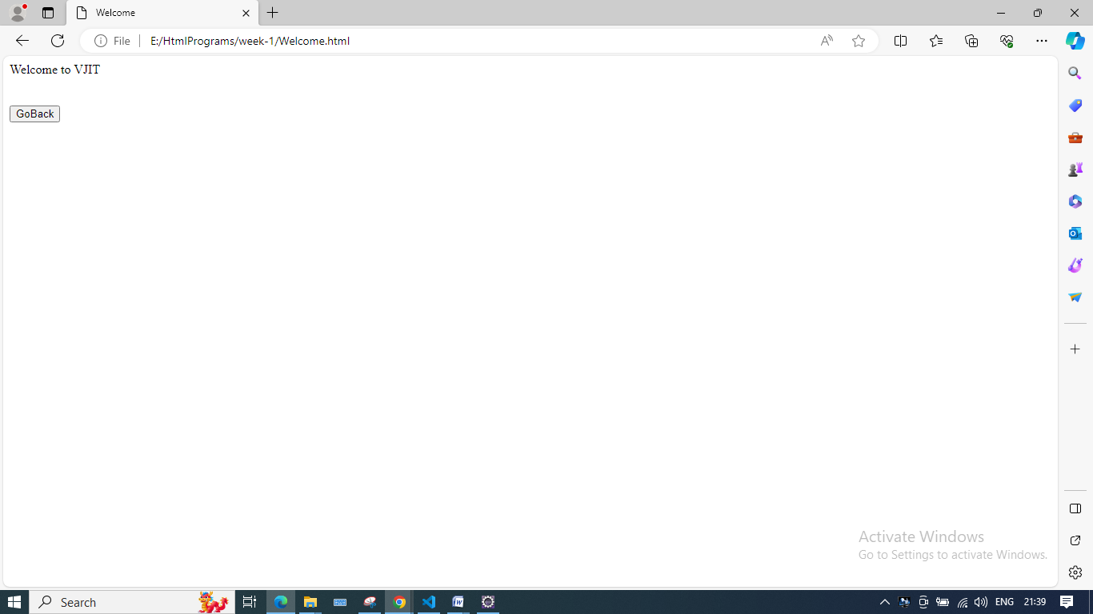

b) Write a HTML program to create a Registration form, which contains User Name, Password, Date of Birth, Gender, Mail-id, Contact number, Address and submit button.

Registration form.html
<html>
<head><title>Registration- Form</title></head>
<body><br/><br/><br/>
<form name="frm1">
<table align="center">
<caption> <font color="red">REGISTRATION</font> </caption>
<tr><td>Name :</td>
<td><input type="text" name="name"></input></td>
</tr>
<tr><td>Password :</td>
<td><input type="password" name="pwd"></input></td>
</tr>
<tr><td>E-Mail :</td>
<td><input type="text" name="email"></input></td>
</tr>
<tr><td>Phone No :</td>
<td><input type="text" name="phno"></input></td>
</tr>
<tr><td>Sex :</td>
<td>
<input type="radio" name="sex">Male</input>&nbsp<input type="radio" name="sex">Female</input>
</td></tr>
<tr><td>D.O.B:</td>
<td>
<select name="day">
<option>1</option><option>2</option>
<option>3</option><option>4</option>
<option>5</option><option>6</option>
<option>7</option><option>8</option>
<option>.....</option>
</select>&nbsp
<select name="month">
<option>1</option><option>2</option>
<option>3</option><option>4</option>
<option>5</option><option>6</option>
<option>7</option><option>8</option>
<option>9</option><option>10</option>
<option>11</option><option>12</option>
</select>&nbsp
<select name="year">
<option>1990</option><option>1991</option>
<option>1992</option><option>1993</option>
<option>1994</option><option>1995</option>
<option>1996</option><option>1997</option>
<option>1998</option><option>1999</option>
</select>
</td>
</tr>
<tr><td>Languages Known :</td>
<td>
<input type="checkbox" name="tel">Telugu</input>&nbsp
<input type="checkbox" name="eng">English</input>&nbsp
<input type="checkbox" name="tam">Tamil</input>&nbsp
<input type="checkbox" name="hin">Hindi</input>&nbsp
</td></tr>
<tr>
<td valign=top>Address :</td>
<td>
<textarea rows=4 cols=30 name="ads"></textarea>
</td></tr>
<tr>
<td align="right">
<input type="button" name="login" value="Submit"></input>
</td>
<td align="center">
<input type="button" name="reset" value="Reset"></input>&nbsp;&nbsp;&nbsp;
<a href="E:\HtmlPrograms\week-1.html"><input type="button" name="GOBAck" value="GoBack"/></a>
</td>
</tr>
</table>
</form>
</body>
</html>
Output:
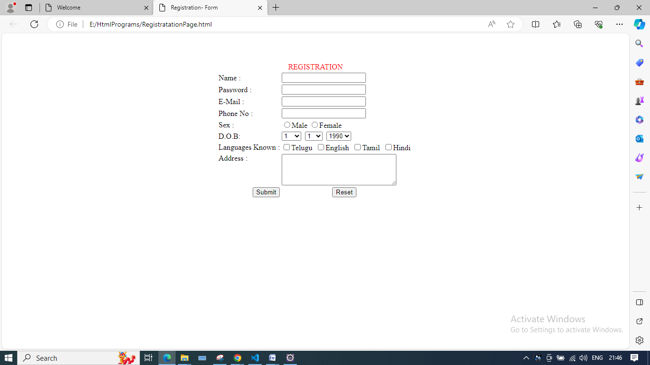

WEEK-2

a)Create a web page to demonstrate Position Property in CSS

The CSS position property is used to align the different elements in the HTML page. CSS position property plays an important role to make high-quality web pages. The CSS position property is used to define the position of the element on the web page. By using the top, left, bottom, right, and z-index, we can identify the exact position of the element.
There are 5 position properties in CSS:
- static (default)
- relative
- absolute
- fixed
- sticky

Syntax:
selector{
position: value;
}
value = static, relative, absolute, fixed, sticky
position: static It is the default position value for the element. Under static position, elements are positioned according to the normal flow of the page.
Note: left, right, top, and bottom properties will not affect if the position is static.
Example: In this example, we will use static css position property.

Postion_static.html
<!DOCTYPE html>
<html lang="en">
<head>
<style>
.purple {
height: 200px;
width: 200px;
color: black;
font-size: 1.5rem;
padding: 10px;
background-color: purple;
}
.cyan {
position: static;
font-size: 1.5rem;
padding: 10px;
height: 200px;
width: 200px;
background-color: cyan;
}
</style>
</head>
<body>
<div class="purple">
I am reference
</div>
<div class="cyan">
I am static element
</div>
</body>
</html>

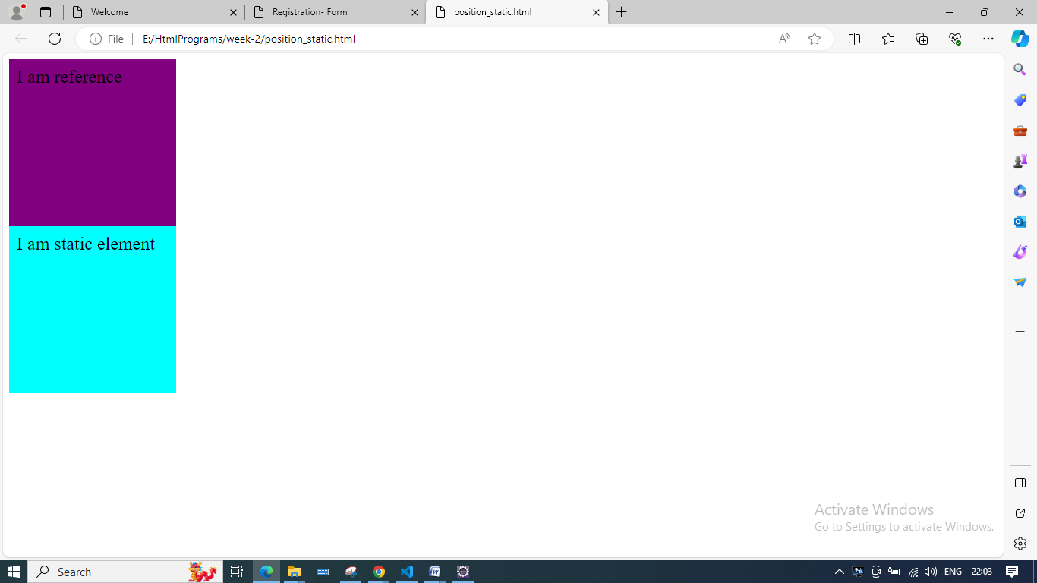

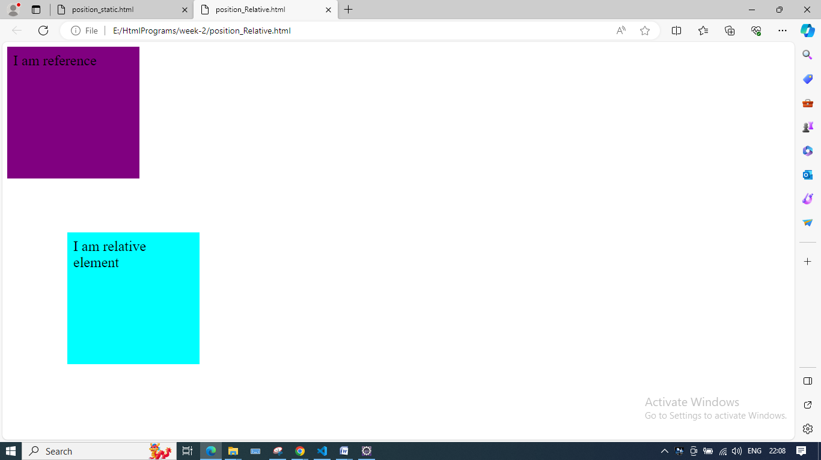
Explanation: We can see here element change its left and top from the original position creating some space.
position: Absolute elements do not follow the normal flow document instead they position themselves relative to the closest positioned ancestor. Its final position is determined using the top, bottom, left and right.
Note: The positioned element means an element having a position property other than static.
These element does not occupy any space and other elements treats absolute elements like there is no element. Parent element should be positioned and position property other than absolute and If parent element is not positioned then absolute element position themselves according to nearest positioned ancestor. We generally set z-index when using absolute position.
Consider Two cases to understand absolute position:
1st case: When the parent property value is positioned means the position property of the parent is not equal to static.
<!DOCTYPE html>
<html lang="en">
<head>
<style>
.purple {
position: relative;
height: 200px;
width: 200px;
color: black;
font-size: 1.5rem;
padding: 10px;
background-color: purple;
}
.cyan {
position: absolute;
bottom: 10px;
left: 70px;
font-size: 1.5rem;
padding: 10px;
height: 100px;
width: 100px;
background-color: cyan;
}
</style>
</head>
<body>
<div class="purple">
I am positioned and parent
<div class="cyan"> I am absolute element </div>
</div>
</body>
</html>

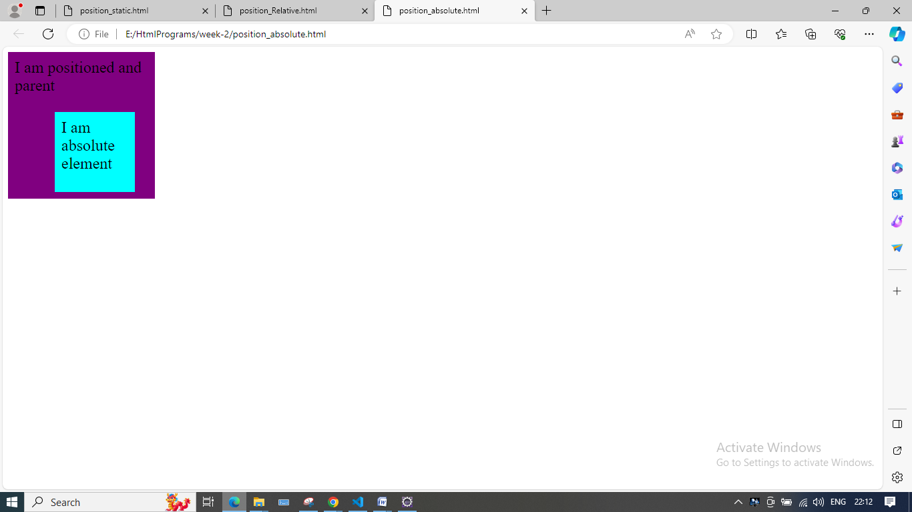

Explanation: Here we can see child element has adjusted itself according to parent and no extra space is assign to it.
2nd Case: When the parent element is not positioned.

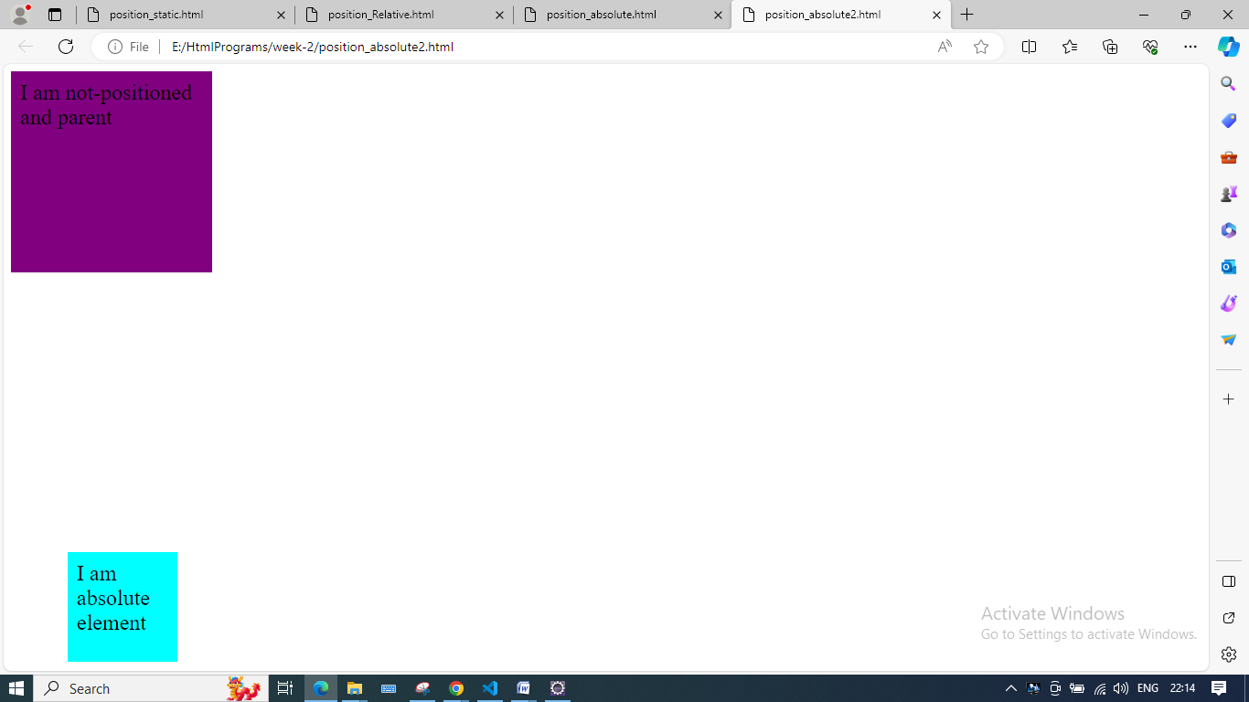
Explanation: As the parent is not positioned, the child element will try to adjust itself relative to nearest positioned ancestor. Here nearest positioned ancestor is <HTML> so element gets adjust according to <HTML>.
position: Fixed Fixed element does not follow normal document flow and positions themselves relative to <HTML> tag. This element always stick to the screen.
Example: In this example, we will use fixed css position property.

<!DOCTYPE html>
<html lang="en">
<head>
<style>
.purple {
position: relative;
height: 2000px;
width: 200px;
color: black;
font-size: 1.5rem;
font-family: sans-serif;
padding: 10px;
background-color: purple;
}
.cyan {
position: fixed;
top: 200px;
left: 10px;
padding: 10px;
font-size: 1rem;
color: black;
height: 100px;
width: 100px;
background-color: cyan;
}
</style>
</head>
<body>
<div class="purple">
I am reference
<div class="cyan">
I am fixed element
</div>
</div>
</body>
</html>

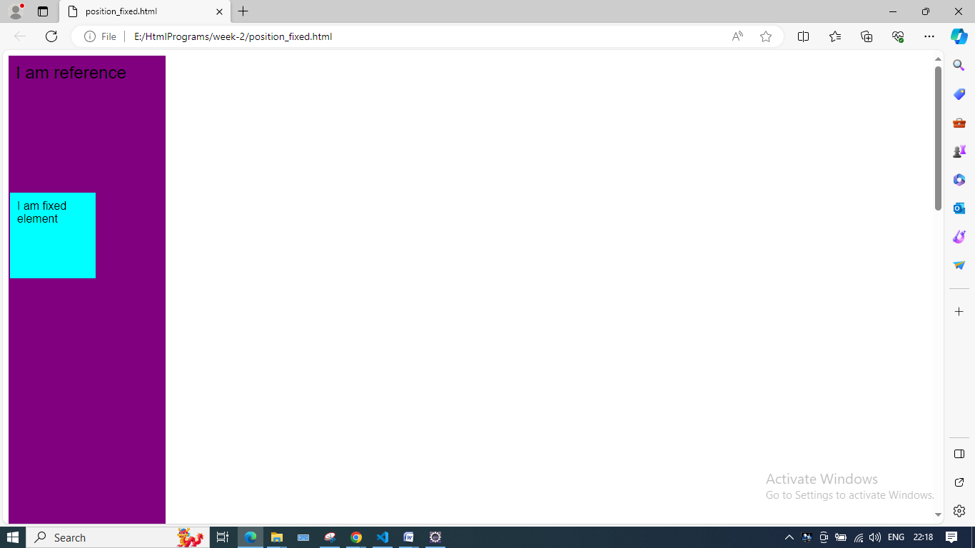

position: sticky It’s kind of a little tricky but very easy to understand. We can think of sticky as a combination of relative and fixed. Remember fixed elements remain fixed at some position but the sticky element will behave relative to a certain point and after behave like a fixed.
Example: In this example, we will use the sticky css position property.
<!DOCTYPE html>
<html lang="en">
<head>
<style>
.purple {
position: absolute;
height: 2000px;
width: 200px;
color: black;
font-size: 1.5rem;
font-family: sans-serif;
padding: 10px;
background-color: purple;
}
.cyan {
position: sticky;
top: 10px;
left: 0px;
padding: 10px;
font-size: 1rem;
color: black;
height: 100px;
width: 100px;
background-color: cyan;
z-index: 2;
}

.yellow {
padding: 10px;
position: relative;
height: 100px;
width: 100px;
background-color: yellow;
}
</style>
</head>
<body>
<div class="purple">
<div class="yellow">I am reference</div>
<div class="cyan">
I am sticky element
</div>
<div class="yellow">I am reference</div>
</div>
</body>
</html>
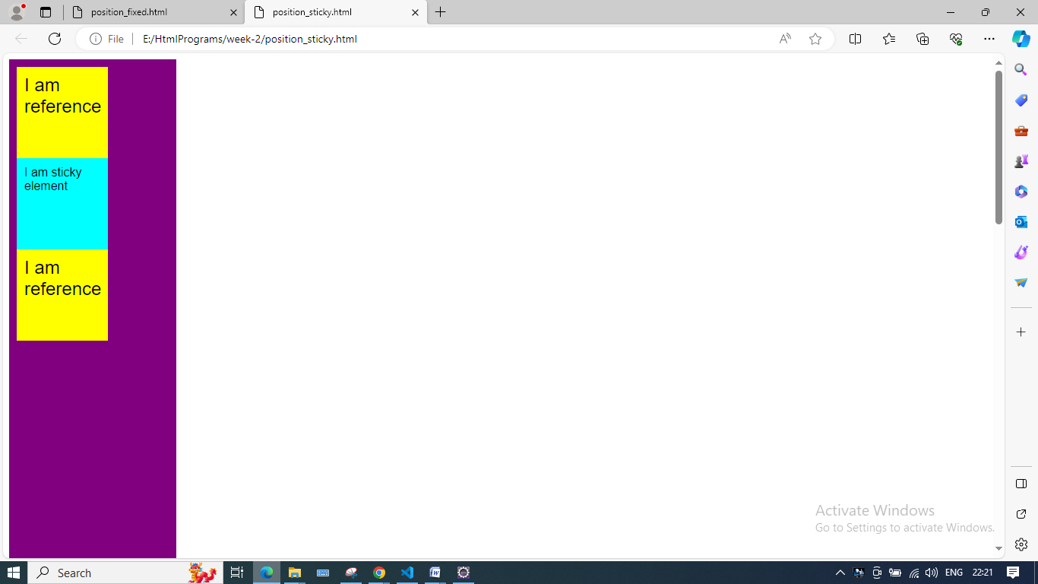
Explanation: In the above output, you can see the sticky element behaves like a relative element until it reaches a particular offset. Then beyond that point, it sticks to the page and behaves like fixed (here that offset is 10px from top).
Note: In sticky left, right, top and bottom does not determine the position of the element in the relative state but it specifies at what position element should behave like fixed.

b) Create a Newspaper Style Design to print minimum 2 articles using HTML and CSS.

Newspaper.css
body{
font-family: 'Droid Serif', serif;
font-size: 14px;
color: #2f2f2f;
background-color: #f9f7f1;
}
header{
font-family: 'Playfair Display', serif;
font-weight: 900;
font-size: 80px;
text-transform: uppercase;
display: inline-block;
line-height: 72px;
margin-bottom: 20px;

}
p{
margin-top: 0;
margin-bottom: 20px;
}
.head{
text-align: center;
position: relative;

}

.headerobjectswrapper{
}

.subhead{
text-transform: uppercase;
border-bottom: 2px solid #2f2f2f;
border-top: 2px solid #2f2f2f;
padding: 12px 0 12px 0;

}
.weatherforcastbox{
position: relative;
width: 12%;
left: 10px;
border: 3px double #2f2f2f;
padding: 10px 15px 10px 15px;
line-height: 20px;
display: inline-block;
margin: 0 50px 20px -360px;
}
.content{
font-size: 0;
line-height: 0;
word-spacing: -.31em;
display: inline-block;
margin: 30px 2% 0 2%;

}
.collumns{

}

.collumn{
font-size: 14px;
line-height: 20px;
width: 17.5%;
display: inline-block;
padding: 0 1% 0 1%;
vertical-align: top;
margin-bottom: 50px;
transition: all .7s;
}
.collumn + .collumn {
border-left: 1px solid #2f2f2f;
}
.collumn .headline{
text-align: center;
line-height: normal;
font-family: 'Playfair Display', serif;
display: block;
margin: 0 auto;

}
.collumn .headline.hl1{
font-weight: 700;
font-size: 30px;
text-transform: uppercase;
padding: 10px 0 10px 0;

}

.collumn .headline.hl2{
font-weight: 400;
font-style: italic;
font-size: 24px;
box-sizing: border-box;
padding: 10px 0 10px 0;
}

.collumn .headline.hl2:before{
border-top: 1px solid #2f2f2f;
content: '';
width: 100px;
height: 7px;
display: block;
margin: 0 auto;
}
.collumn .headline.hl2:after{
border-bottom: 1px solid #2f2f2f;
content: '';
width: 100px;
height: 13px;
display: block;
margin: 0 auto;

}

.collumn .headline.hl3{
font-weight: 400;
font-style: italic;
font-size: 36px;
box-sizing: border-box;
padding: 10px 0 10px 0;
}
.collumn .headline.hl4{
font-weight: 700;
font-size: 12px;
box-sizing: border-box;
padding: 10px 0 10px 0;
}
.collumn .headline.hl4:before{
border-top: 1px solid #2f2f2f;
content: '';
width: 100px;
height: 7px;
display: block;
margin: 0 auto;
}
.collumn .headline.hl4:after{
border-bottom: 1px solid #2f2f2f;
content: '';
width: 100px;
height: 10px;
display: block;
margin: 0 auto;

}

.collumn .headline.hl5{
font-weight: 400;
font-size: 42px;
text-transform: uppercase;
font-style: italic;
box-sizing: border-box;
padding: 10px 0 10px 0;
}
.collumn .headline.hl6{
font-weight: 400;
font-size: 18px;
box-sizing: border-box;
padding: 10px 0 10px 0;
}
.collumn .headline.hl6:before{
border-top: 1px solid #2f2f2f;
content: '';
width: 100px;
height: 7px;
display: block;
margin: 0 auto;
}
.collumn .headline.hl6:after{
border-bottom: 1px solid #2f2f2f;
content: '';
width: 100px;
height: 10px;
display: block;
margin: 0 auto;

}
.collumn .headline.hl7{
font-weight: 700;
font-size: 12px;
box-sizing: border-box;
display: block;
padding: 10px 0 10px 0;
}
.collumn .headline.hl8{
font-weight: 700;
font-size: 12px;
box-sizing: border-box;
padding: 10px 0 10px 0;
}
.collumn .headline.hl9{
font-weight: 700;
font-size: 12px;
box-sizing: border-box;
padding: 10px 0 10px 0;
}
.collumn .headline.hl10{
font-weight: 700;
font-size: 12px;
box-sizing: border-box;
padding: 10px 0 10px 0;
}
.collumn .citation{
font-family: 'Playfair Display', serif;
font-size: 36px;
line-height: 44px;
/*font-style: italic;*/
text-align: center;
font-weight: 400;
display: block;
margin: 40px 0 40px 0;
font-feature-settings: "liga", "dlig";

}
.collumn .citation:before{
border-top: 1px solid #2f2f2f;
content: '';
width: 100px;
height: 16px;
display: block;
margin: 0 auto;
}
.collumn .citation:after{
border-bottom: 1px solid #2f2f2f;
content: '';
width: 100px;
height: 16px;
display: block;
margin: 0 auto;
}
.collumn .figure {
margin: 0 0 20px;
}
.collumn .figcaption{
font-style: italic;
font-size: 12px;
}
.media {
-webkit-filter: sepia(80%) contrast(1) opacity(0.8);
filter: sepia(80%) grayscale(1) contrast(1) opacity(0.8);
mix-blend-mode: multiply;
width: 100%;
}
/*________________________________________________________________________________________________________________________________*/
/*MEDIAQUERIES*/
@media only all and (max-width: 1300px) {
.weatherforcastbox{
display: none;
}

}
@media only all and (max-width: 1200px) {
.collumn{
width: 31%;
}

}
@media only all and (max-width: 900px) {
.collumn{
width: 47%;
}

}
@media only all and (max-width: 600px) {
.collumn{
width: 100%;
}
.collumn + .collumn {
border-left: none;
border-bottom: 1px solid #2f2f2f;
}
header{
max-width: 320px;
font-size: 60px;
line-height: 54px;
overflow: hidden;
}

}

Newspaper.html
<html>
<head>
<link href='https://fonts.googleapis.com/css?family=Playfair+Display:400,700,900,400italic,700italic,900italic|Droid+Serif:400,700,400italic,700italic' rel='stylesheet' type='text/css'>
<link rel="stylesheet" href="newspaper.css">
<title>Newspaper Style Design Experiment</title>
<meta name="viewport" content="width=device-width">

</head>
<body>
<div class="head">
<div class="headerobjectswrapper">
<div class="weatherforcastbox"><span style="font-style: italic;">Weatherforcast for the next 24 hours: Plenty of Sunshine</span><br><span>Wind: 7km/h SSE; Ther: 21°C; Hum: 82%</span></div>
<header>Newpost York</header>
</div>

<div class="subhead">York, MA - Thursday August 30, 1978 - Seven Pages</div>
</div>
<div class="content">
<div class="collumns">
<div class="collumn">
<div class="head"><span class="headline hl3">When darkness overspreads my eyes</span><p><span class="headline hl4">by JOHANN WOLFGANG VON GOETHE</span></p></div>
When, while the lovely valley teems with vapour around me, and the meridian sun strikes the upper surface of the impenetrable foliage of my trees, and but a few stray gleams steal into the inner sanctuary, I throw myself down among the tall grass by the trickling stream;<p>and, as I lie close to the earth, a thousand unknown plants are noticed by me: when I hear the buzz of the little world among the stalks, and grow familiar with the countless indescribable forms of the insects and flies, then I feel the presence of the Almighty, who formed us in his own image, and the breath of that universal love which bears and sustains us, as it floats around us in an eternity of bliss; and then, my friend, when darkness overspreads my eyes, and heaven and earth seem to dwell in my soul and absorb its power, like the form of a beloved mistress, then I often think with longing, Oh, would I could describe these conceptions, could impress upon paper all that is living so full and warm within me, that it might be the mirror of my soul, as my soul is the mirror of the infinite God!</p></div>
<div class="collumn">
<div class="head"><span class="headline hl5">Give people courage</span><p><span class="headline hl6">The crowd seemed to grow</span></p></div>
The sunset faded to twilight before anything further happened. The crowd far away on the left, towards Woking, seemed to grow, and I heard now a faint murmur from it. The little knot of people towards Chobham dispersed. There was scarcely an intimation of movement from the pit.</p>
<figure class="figure">
<img class="media" src="http://i.giphy.com/PW7MoTD2d9pJK.gif" alt="">
<figcaption class="figcaption">Hermine hoping for courage.</figcaption>
</figure>

<p>It was this, as much as anything, that gave people courage, and I suppose the new arrivals from Woking also helped to restore confidence. At any rate, as the dusk came on a slow, intermittent movement upon the sand pits began, a movement that seemed to gather force as the stillness of the evening about the cylinder remained unbroken. Vertical black figures in twos and threes would advance, stop, watch, and advance again, spreading out as they did so in a thin irregular crescent that promised to enclose the pit in its attenuated horns. I, too, on my side began to move towards the pit.</p>

<p>Then I saw some cabmen and others had walked boldly into the sand pits, and heard the clatter of hoofs and the gride of wheels. I saw a lad trundling off the barrow of apples. And then, within thirty yards of the pit, advancing from the direction of Horsell, I noted a little black knot of men, the foremost of whom was waving a white flag.</p>

</div>
<div class="collumn"><div class="head"><span class="headline hl1">May the Force be with you</span><p><span class="headline hl2">Let go your conscious self and act on instinct</span></p></div>Partially, but it also obeys your commands. Hey, Luke! May the Force be with you. I have traced the Rebel spies to her. Now she is my only link to finding their secret base.</p>
<figure class="figure">
<img class="media" src="http://i.giphy.com/4fDWVPMoSyhgc.gif" alt="">
<figcaption class="figcaption">"This time, let go your conscious self and act on instinct."</figcaption>
</figure>
<p>Leave that to me. Send a distress signal, and inform the Senate that all on board were killed. <span class="citation">"Don't under&shy;estimate the Force. I suggest you try it again, Luke."</span> This time, let go your conscious self and act on instinct. In my experience, there is no such thing as luck. You're all clear, kid. Let's blow this thing and go home!</p>
<p>You don't believe in the Force, do you? Partially, but it also obeys your commands. The plans you refer to will soon be back in our hands. As you wish.</p></div>
<div class="collumn"><div class="head"><span class="headline hl3">The buzz of the little world </span><p><span class="headline hl4">A thousand unknown plants</span></p></div><p>I should be incapable of drawing a single stroke at the present moment; and yet I feel that I never was a greater artist than now. When, while the lovely valley teems with vapour around me, and the meridian sun strikes the upper surface of the impenetrable foliage of my trees, and but a few stray gleams steal into the inner sanctuary, I throw myself down among the tall grass by the trickling stream; and, as I lie close to the earth, a thousand unknown plants are noticed by me: when I hear the buzz of the little world among the stalks, and grow familiar with the countless indescribable forms of the insects and flies, then I feel the presence of the Almighty, who formed us in his own image, and the breath</p></div>
<div class="collumn"><div class="head"><span class="headline hl1">It wasn't a dream </span><p><span class="headline hl4">by FRANZ KAFKA</span></p></div><p>One morning, when Gregor Samsa woke from troubled dreams, he found himself transformed in his bed into a horrible vermin. He lay on his armour-like back, and if he lifted his head a little he could see his brown belly, slightly domed and divided by arches into stiff sections. The bedding was hardly able to cover it and seemed ready to slide off any moment. </p>

<p>His many legs, pitifully thin compared with the size of the rest of him, waved about helplessly as he looked. "What's happened to me?" he thought. It wasn't a dream. His room, a proper human room although a little too small, lay peacefully between its four familiar walls. A collection of textile samples lay spread out on the table - Samsa was a travelling salesman - and above it there hung a picture that he had recently cut out of an illustrated magazine and housed in a nice, gilded frame. It showed a lady fitted out with a fur hat and fur boa who sat upright, raising a heavy fur muff that covered the whole of her lower arm towards the viewer. Gregor then turned to look out the window at the dull weather. </p></div>
</div>
</div>

</body>
</html>
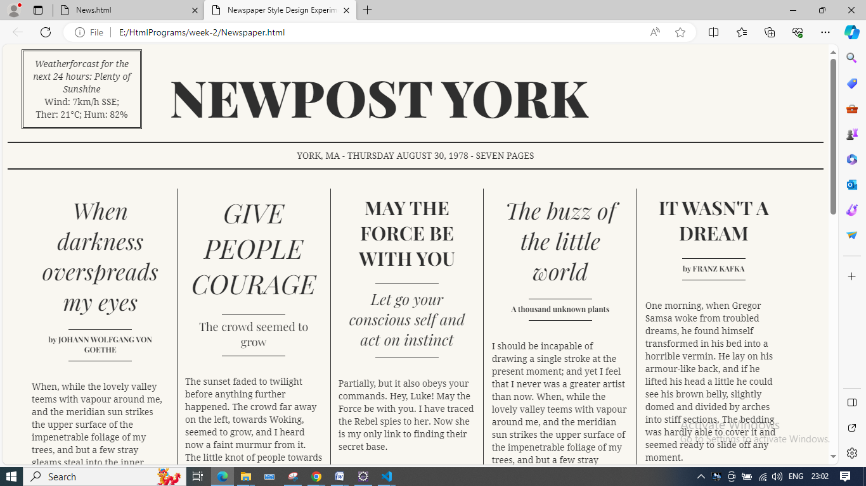

WEEK-3
- Write a JavaScript program to change the background color after clicking “change color” button.
ChangeColor.html
<html>
<head>
<script>
function changeColor()
{
var color = document.getElementById('color').value;
var body = document.getElementsByTagName('body')[0];

body.style.backgroundColor=color;

}
</script>
</head>

<body>
<input type="text" id="color" placeholder="#FFFFFF">

<br><br>

<button onclick="changeColor()">Change Color</button>
</body>
</html>

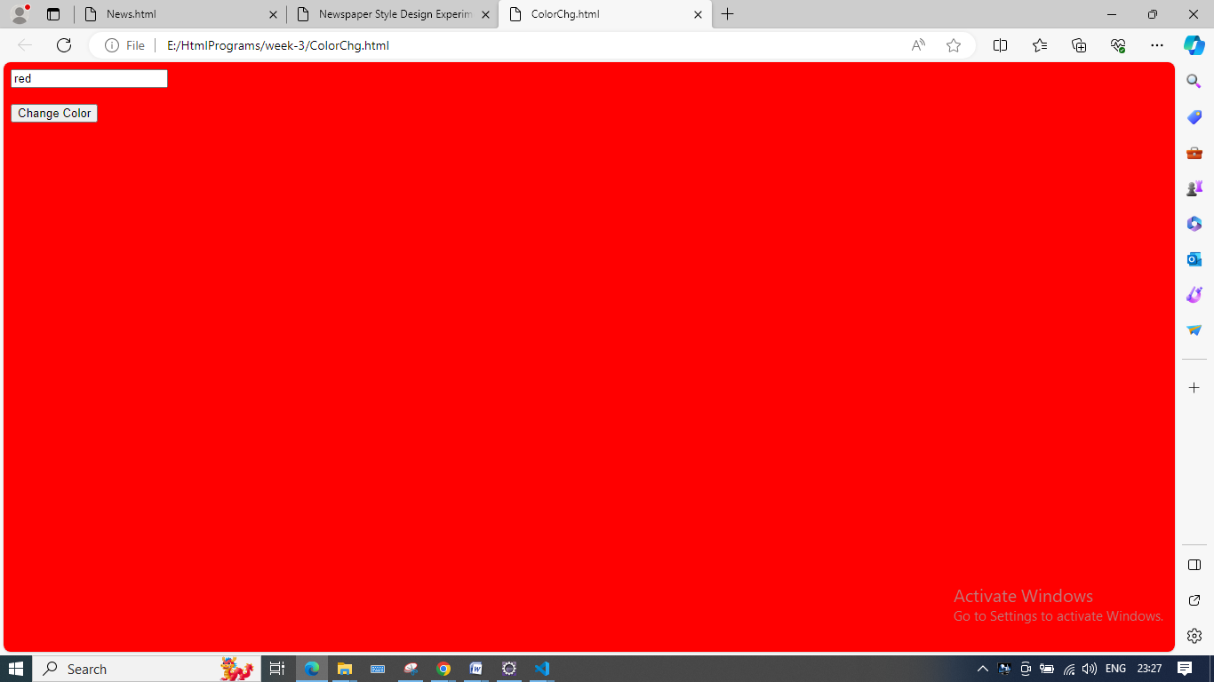

b)Write a JavaScript program to validate registration page using regular expression.

Registration Page.html

<html>

<head>

<title> Registration Page </title>

</head>

<body style="background-color : lightblue">

<h2 align="center"> Registration Page </h2>

<form name="myForm" action="Success.html" onsubmit="return

validateForm()" method="post">

<label>Name*</label>

<input type="text" id="nametxt" size="20" ><br><br>

<label>Password*</label>

<input type="text" id="pwdtxt" size="20" ><br><br>

<label>Email*</label>

<input type="text" id="emailtxt" size="30"><br><br>

<label>Phone no*</label>

<input type="text" id="phtxt" size="20" ><br><br>

<label>Gender</label>

<input type="radio" name="gender" id="m" value="m">Male

<input type="radio" name="gender" id="f" value="f">Female <br><br>

<label> Date of Birth</label>

<input type="date" id="bday" ><br><br>

<label> Languages Known </label>

<div class="checkboxgroup" >

<input type="checkbox" name="lang"> English &nbsp; &nbsp;&nbsp;

<input type="checkbox" name="lang"> Telugu &nbsp; &nbsp; &nbsp;

<input type="checkbox" name="lang"> Hindi <br><br>

</div>

<label> Address </label> <br>

<textarea rows=5 cols=50 id="addtxtarea" scrolling="yes"></textarea>

</p>

<input type="Submit" value="Register"/>

<script>

function validateForm()

{

var name = document.getElementById("nametxt").value;

var pwd = document.getElementById("pwdtxt").value;

var mobile = document.getElementById("phtxt").value;

var email = document.getElementById("emailtxt").value;

//name validation

if (name.length < 6)

{

alert("The name must be min 6 chars");

return false;

}

//password validation

if (pwd.length < 6)

{

alert("The password must be min 6 chars");

return false;

}

//email validation

var filter = /^([a-zA-Z0-9_\.\-])+\@(([a-zA-Z0-9\-])+\.)+([a-zAZ0-9]{2,4})+$/;

if(email.match(filter))

{

}

else

{

alert("Not a valid Email ID");

return false;

}

//phone number validation

var phoneno = /^\d{10}$/;

if(mobile.match(phoneno))

{

}

else

{

alert("Not a valid Phone Number");

return false;

}

}

</script>

</form>

</body>

</html>

Success.html

<html>

<body>

<h1> Successfully Registered.. </h1>

</body>

</html>

OUTPUT:

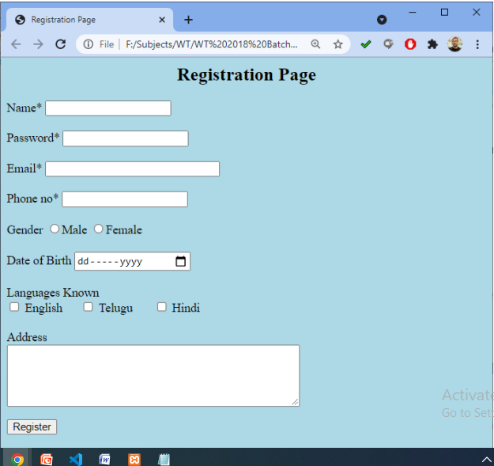

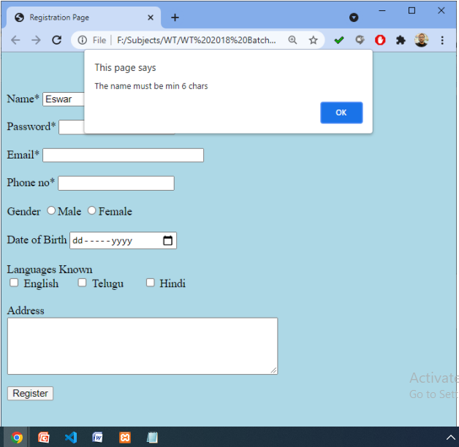

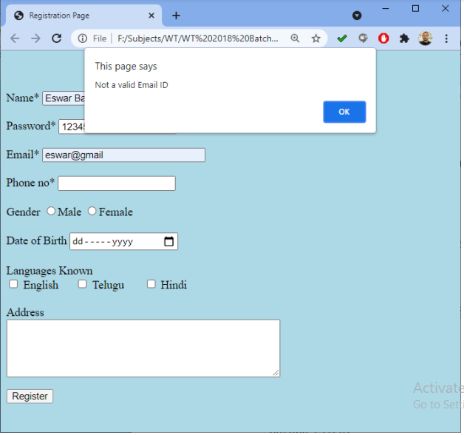

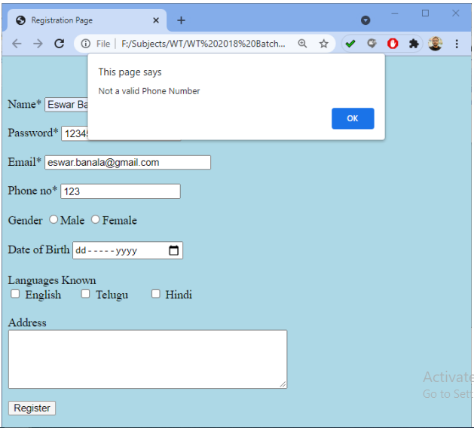

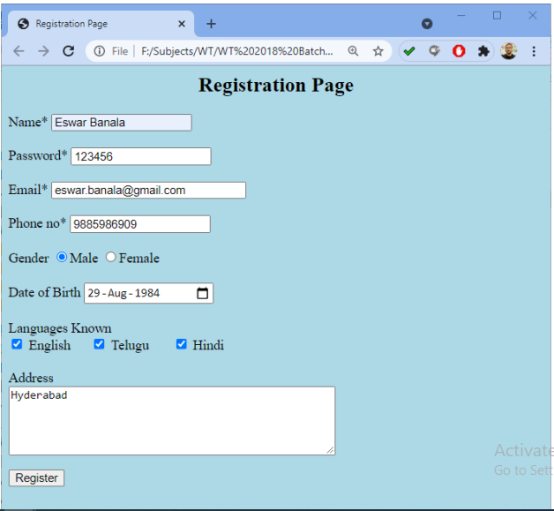

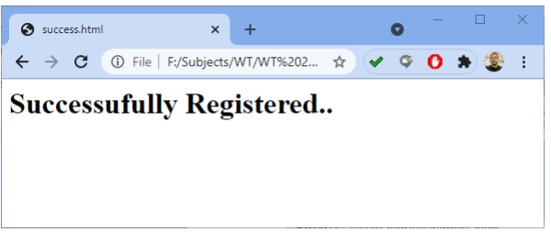
WEEK-4
4. a) Write a code to hide and show an element in a periodic interval without any action from the user using JQuery.

<!DOCTYPE html>

<html>

<head>

<script src="https://ajax.googleapis.com/ajax/libs/jquery/3.7.0/jquery.min.js"></script>

<script>

$(document).ready(function() {

$("div").hide();

setTimeout(function(){

$("div").show();

},3000); // 3000 milliseconds = 3 seconds

});

</script>

</head>

<body>

<p>After 3000 milliseconds = 3 seconds It will Shows the Message.</p>

<div>

The requested operation is completed successfully!

</div>

</body>

</html>

Output:

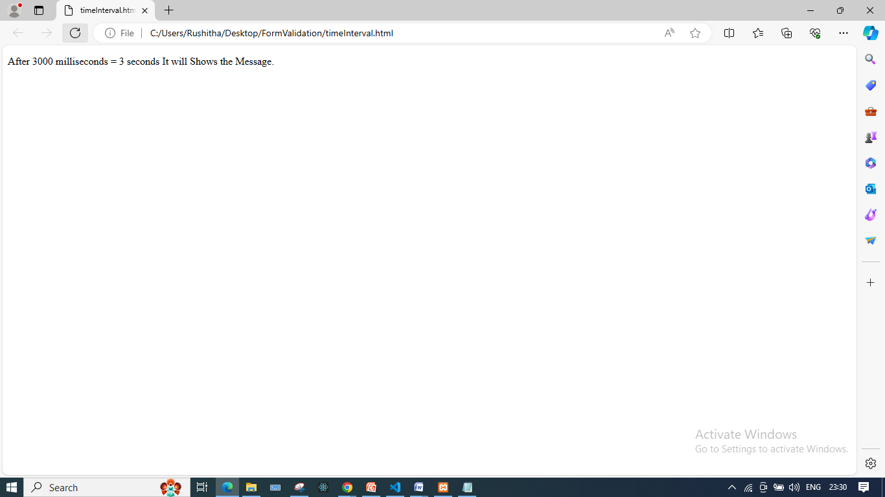
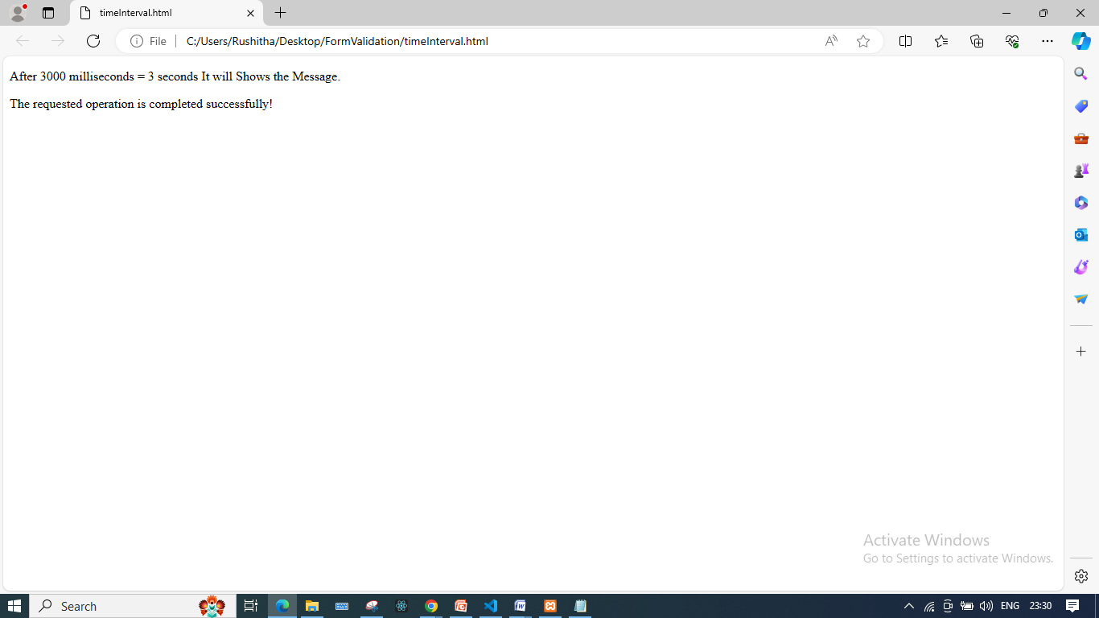

b)Write a program to create and Build a star rating system using JQuery.

<!DOCTYPE html>
<html lang = "en">
<head>
<meta charset = "UTF-8">
<meta name = "viewport" content="width=device-width, initial-scale=1.0">
<link rel = "stylesheet" href = "https://cdnjs.cloudflare.com/ajax/libs/twitter-bootstrap/4.4.1/css/bootstrap.min.css">
<script src = "https://cdnjs.cloudflare.com/ajax/libs/jquery/3.4.1/jquery.js"> </script>
<script src = "https://cdnjs.cloudflare.com/ajax/libs/twitter-bootstrap/4.4.1/js/bootstrap.min.js"> </script>
<link rel = "stylesheet" href = "https://cdnjs.cloudflare.com/ajax/libs/font-awesome/4.7.0/css/font-awesome.min.css">
<script src = "https://ajax.googleapis.com/ajax/libs/jquery/3.5.1/jquery.min.js"></script>
<title> jQuery simple star rating example </title>
<style>
body {
background-color: aquamarine;
margin : 0px;
}
.fa-star {
font-size : 50px;
align-content: center;
}
.container {
height: 100px;
width: 600px;
margin: auto;
}
</style>
</head>
<body>
<div class = "container">
<h2 style="margin-top: 50px;">jQuery simple star rating example</h2>
<div class = "con">
<h3 style = "margin-top : 80px; color: green;">Rate our product :-</h3>
<i class = "fa fa-star" aria-hidden = "true" id = "st1"></i>
<i class = "fa fa-star" aria-hidden = "true" id = "st2"></i>
<i class = "fa fa-star" aria-hidden = "true" id = "st3"></i>
<i class = "fa fa-star" aria-hidden = "true" id = "st4"></i>
<i class = "fa fa-star" aria-hidden = "true" id = "st5"></i>
</div>
</div>
<script>
$(document).ready(function() {
$("#st1").click(function() {
$(".fa-star").css("color", "black");
$("#st1").css("color", "yellow");

});
$("#st2").click(function() {
$(".fa-star").css("color", "black");
$("#st1, #st2").css("color", "yellow");

});
$("#st3").click(function() {
$(".fa-star").css("color", "black")
$("#st1, #st2, #st3").css("color", "yellow");

});
$("#st4").click(function() {
$(".fa-star").css("color", "black");
$("#st1, #st2, #st3, #st4").css("color", "yellow");

});
$("#st5").click(function() {
$(".fa-star").css("color", "black");
$("#st1, #st2, #st3, #st4, #st5").css("color", "yellow");

});
});
</script>
</body>
</html>
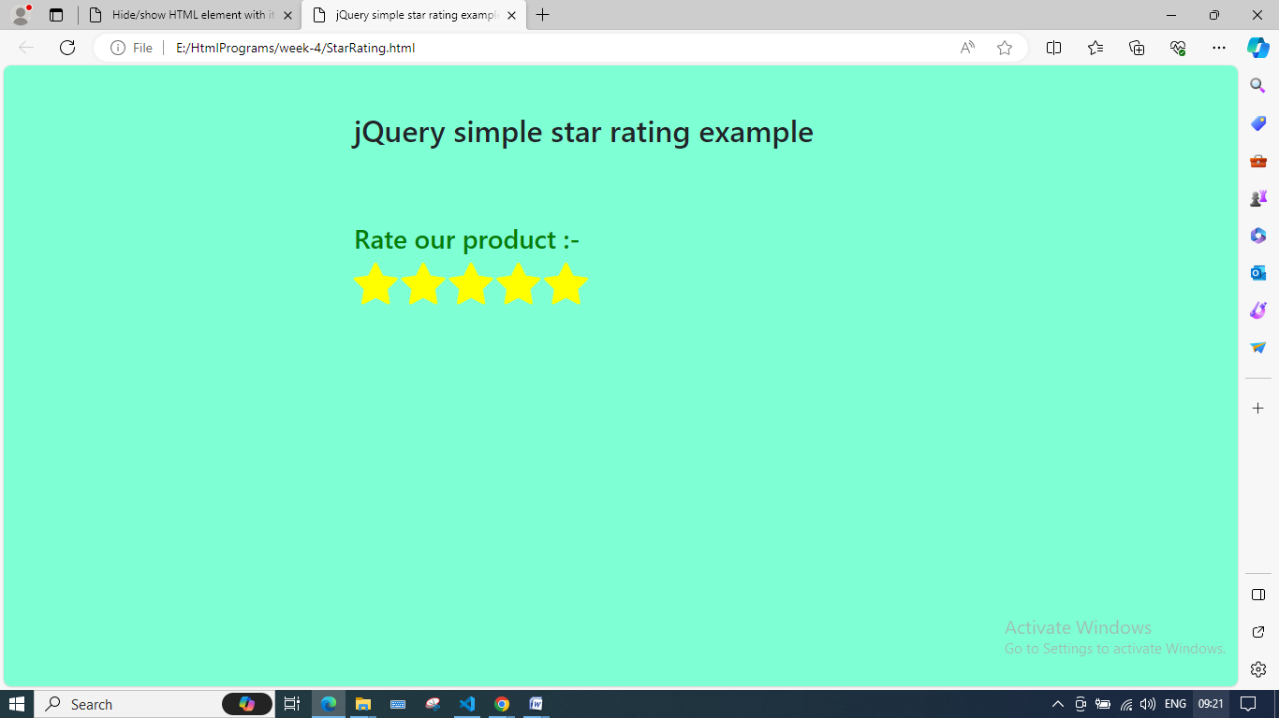

WEEK-5
a)Write a program to demonstrate ReactJS Class and Instance.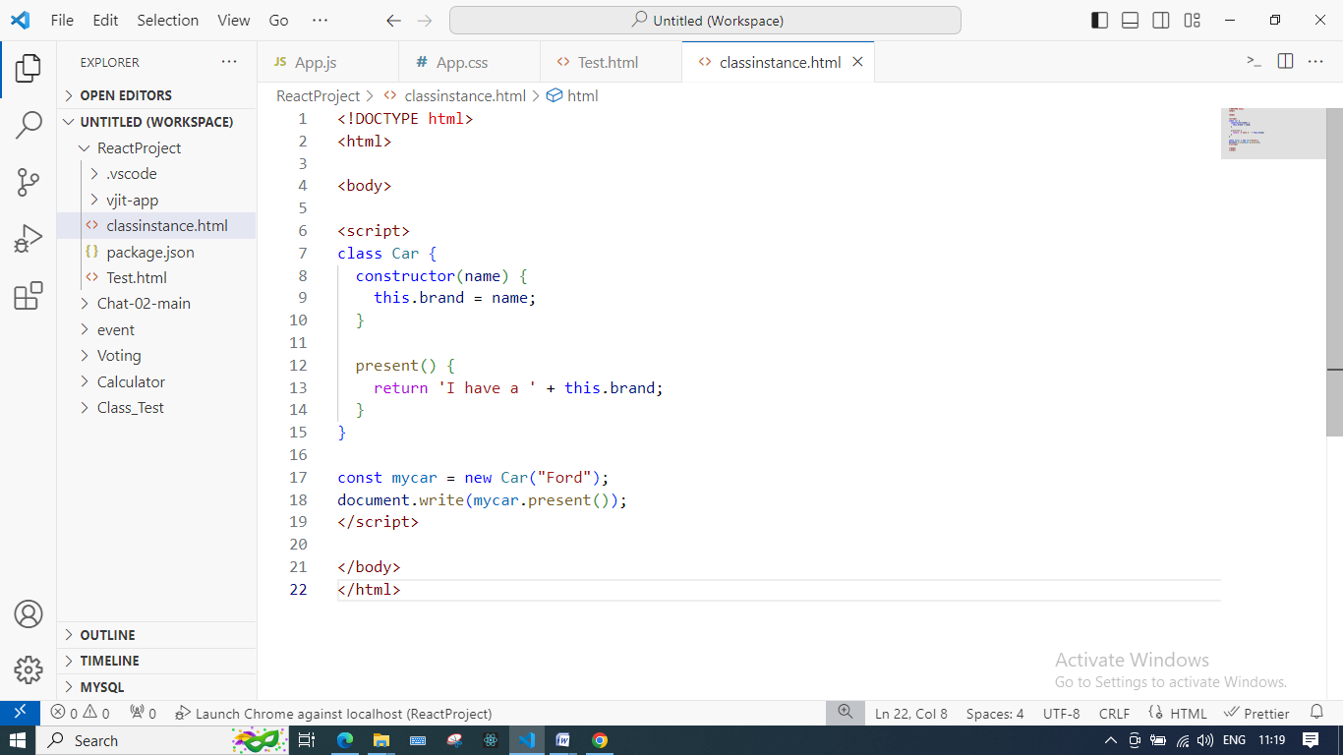

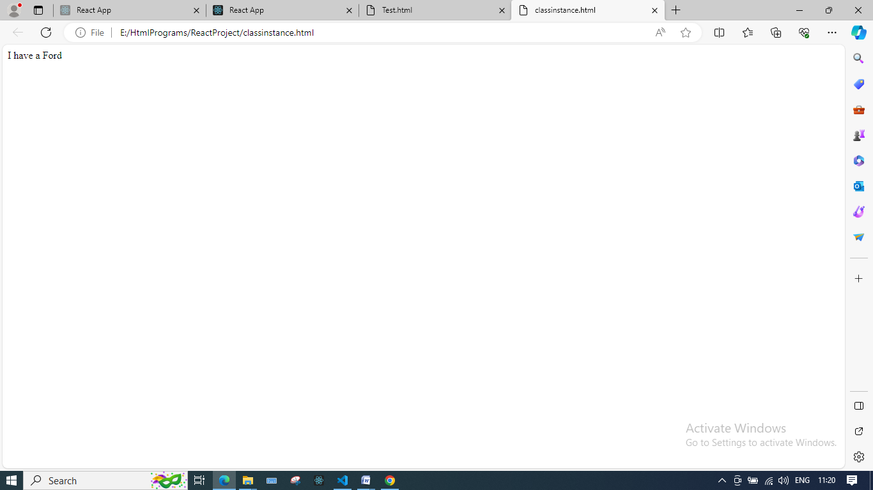
b)Write a program to create a basic calculator to perform arithmetic operations using ReactJS.
Example Project for Calculator
To create the example project for this example, open command prompt, navigate to a convenient location, and run the command as shown below :
create-react-app example4
Now just replace the placeholder content of App.js and App.css with given below content :

src\App.js
import React, { Component } from 'react';
import './App.css';

class App extends Component {
constructor(props){
super(props);
this.state = {
display: "0",
equation: ""
}
this.numInput = this.numInput.bind(this);
this.operInput = this.operInput.bind(this);
this.decInput = this.decInput.bind(this);
this.clearInput = this.clearInput.bind(this);
this.calculate = this.calculate.bind(this);
}

numInput(e){
if(this.state.equation.match(/[0-9\.]$/) && !this.state.equation.includes("=")){
if(this.state.equation.match(/[+\-*\/]/) == null){
let val = this.state.equation + e.currentTarget.value;
this.setState({
display: val,
equation: val
});
} else {
this.setState({
display: this.state.display + e.currentTarget.value,
equation: this.state.equation + e.currentTarget.value
});
}
} else if(this.state.equation.match(/[+\-*\/]$/)){
let val = this.state.equation + e.currentTarget.value;
this.setState({
display: e.currentTarget.value,
equation: val
});
} else if(this.state.display === "0" && e.currentTarget.value !== "0" || this.state.equation.includes("=")) {
this.setState({
display: e.currentTarget.value,
equation: e.currentTarget.value
});
}
}

operInput(e){
if(this.state.equation.includes("=")){
let val = this.state.display;
val += e.currentTarget.value;
this.setState({
equation: val
});
} else {
if(this.state.equation != "" && this.state.equation.match(/[*\-\/+]$/) == null){
let val = this.state.equation;
val += e.currentTarget.value;
this.setState({
equation: val
});
} else if(this.state.equation.match(/[*\-\/+]$/) != null){
let val = this.state.equation;
val = val.substring(0, (val.length-1));
val += e.currentTarget.value;
this.setState({
equation: val
});
}
}
}

decInput(e){
if(this.state.equation == "" || this.state.equation.includes("=")){
let val = '0.';
this.setState({
display: val,
equation: val
});
} else if(this.state.equation.match(/[+\-*\/]$/)){
let val = '0.';
this.setState({
display: val,
equation: this.state.equation + val
});
} else if(!this.state.display.includes(".")){
this.setState({
display: this.state.display + e.currentTarget.value,
equation: this.state.equation + e.currentTarget.value
});
}
}

clearInput(){
this.setState({
display: "0",
equation: ""
});
}

calculate(){
if(this.state.equation.includes("=")){
let val = `${this.state.display} = ${this.state.display}`;
this.setState({
equation: val
});
} else if(this.state.equation != "" && this.state.equation.match(/[+\-*\/]/) != null && this.state.equation.match(/[+\-*\/]$/) == null) {
let result = Number.isInteger(eval(this.state.equation)) ? eval(this.state.equation) : parseFloat(eval(this.state.equation).toFixed(5));
let val = this.state.equation;
val += ` = ${result}`;
this.setState({
display: result,
equation: val
});
}
}

render() {
return (
<div className="container">
<Display equation={this.state.equation} display={this.state.display} />
<Button id="clear" value="clear" display="AC" class="row-3 col-1" click={this.clearInput} />
<Button id="sign" value="+/-" display="±" class="row-3 col-2" />
<Button id="percent" value="%" display="%" class="row-3 col-3" />
<Button id="divide" value="/" display="÷" class="oper row-3 col-4" click={this.operInput} />
<Button id="seven" value="7" display="7" class="num row-4 col-1" click={this.numInput} />
<Button id="eight" value="8" display="8" class="num row-4 col-2" click={this.numInput} />
<Button id="nine" value="9" display="9" class="num row-4 col-3" click={this.numInput} />
<Button id="multiply" value="*" display="×" class="oper row-4 col-4" click={this.operInput} />
<Button id="four" value="4" display="4" class="num row-5 col-1" click={this.numInput} />
<Button id="five" value="5" display="5" class="num row-5 col-2" click={this.numInput} />
<Button id="six" value="6" display="6" class="num row-5 col-3" click={this.numInput} />
<Button id="subtract" value="-" display="−" class="oper row-5 col-4" click={this.operInput} />
<Button id="one" value="1" display="1" class="num row-6 col-1" click={this.numInput} />
<Button id="two" value="2" display="2" class="num row-6 col-2" click={this.numInput} />
<Button id="three" value="3" display="3" class="num row-6 col-3" click={this.numInput} />
<Button id="add" value="+" display="+" class="oper row-6 col-4" click={this.operInput} />
<Button id="zero" value="0" display="0" class="num row-7 col-1-2" click={this.numInput} />
<Button id="decimal" value="." display="." class="num row-7 col-3" click={this.decInput} />
<Button id="equals" value="=" display="=" class="oper row-7 col-4" click={this.calculate} />
</div>
);
}
}

const Display = props => <div id="calc-display" className="row-1-2 col-1-4"><span id="eq">{props.equation}</span><span id="dis">{props.display}</span></div>;

const Button = props => <button type="button" id={props.id} value={props.value} className={props.class} onClick={props.click}>{props.display}</button>;

export default App;
In React we need to create a constructor function for our classes that extend React classes. We are passing an argument into super(props) called "props" this will also be available in the Component constructor class. The super() function will make this available in the constructor method.

src\App.css
@font-face {
font-family: "Digital";
src: url("//db.onlinewebfonts.com/t/8e22783d707ad140bffe18b2a3812529.eot");
src: url("//db.onlinewebfonts.com/t/8e22783d707ad140bffe18b2a3812529.eot?#iefix") format("embedded-opentype"), url("//db.onlinewebfonts.com/t/8e22783d707ad140bffe18b2a3812529.woff2") format("woff2"), url("//db.onlinewebfonts.com/t/8e22783d707ad140bffe18b2a3812529.woff") format("woff"), url("//db.onlinewebfonts.com/t/8e22783d707ad140bffe18b2a3812529.ttf") format("truetype"), url("//db.onlinewebfonts.com/t/8e22783d707ad140bffe18b2a3812529.svg#Digital-7") format("svg");
}

body {
height: 95vh;
width: 95vw;
background-color:#696969;
}
main { height: 100%; }
.container {
height: 100%;
display: grid;
grid-template-columns: 30% repeat(4, 10%) 30%;
grid-template-rows: 12.5% 5% 20% repeat(5, 10%) 12.5%;
}

/* Grid Classes - Columns */
.col-1 { grid-column: 2 / 3; }
.col-2 { grid-column: 3 / 4; }
.col-3 { grid-column: 4 / 5; }
.col-4 { grid-column: 5 / 6; }
.col-1-2 { grid-column: 2 / 4; }
.col-1-4 { grid-column: 2 / 6; }
/* Grid Classes - Rows */
.row-1 { grid-row: 2 / 3; }
.row-2 { grid-row: 3 / 4; }
.row-3 { grid-row: 4 / 5; }
.row-4 { grid-row: 5 / 6; }
.row-5 { grid-row: 6 / 7; }
.row-6 { grid-row: 7 / 8; }
.row-7 { grid-row: 8 / 9; }
.row-1-2 { grid-row: 2 / 4; }

/* Calculator Display */
#calc-display {
width: 100%;
height: 100%;
background-color: black;
color: white;
display: flex;
flex-direction: column;
justify-content: center;
align-items: flex-end;
font-family: digital;
}
#dis, #eq { padding-right: 10%; }
#dis {
font-size: 4vw;
margin-top: 20px;
}
#eq { font-size: 1.5vw; }

/* Calculator Buttons */
button {
-webkit-appearance: none;
-moz-appearance: none;
appearance: none;
display: inline-block;
margin: 0;
text-align: center;
text-decoration: none;
border: 1px solid black;
cursor: grab;
font-size: 2.5em;
}
button:hover {
opacity: 0.7;
border: 1.5px solid white;
}
button:focus { outline: 0; }
.num { background-color: #A9A9A9; }
.oper { background-color: orange; }

/* Responsive for Small Screens */
@media only screen and (max-width: 767px) {
.container{
grid-template-columns: 6% repeat(4, 22%) 6%;
grid-template-rows: 5% 5% 20% repeat(5, 13%) 5%;
}
#dis { font-size: 12vw; }
#eq { font-size: 4vw; }
}
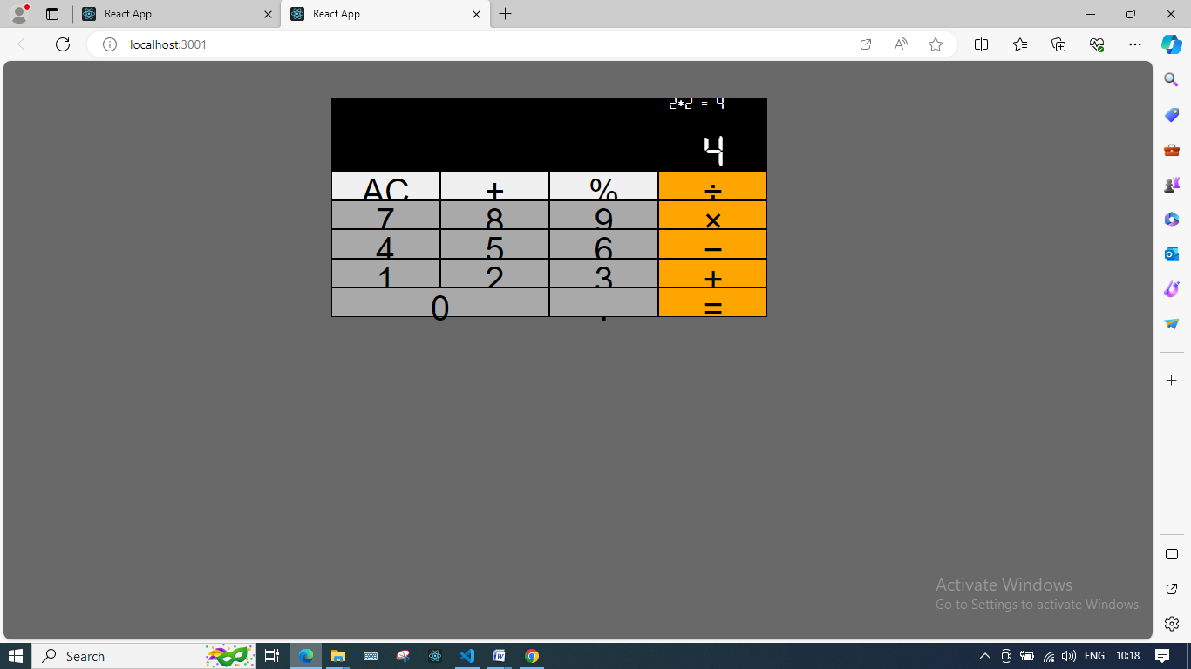

WEEK-6
a)Demonstrate simple event handling example using ReactJS
import React, { Component } from 'react';
class App extends React.Component {
constructor(props) {
super(props);
this.state = {
companyName: ''
};
}
changeText(event) {
this.setState({
companyName: event.target.value
});
}
render() {
return (
<div>
<h2>Simple Event Example</h2>
<label htmlFor="name">Enter company name: </label>
<input type="text" id="companyName" onChange={this.changeText.bind(this)}/>
<h4>You entered: { this.state.companyName }</h4>
</div>
);
}
}
export default App;

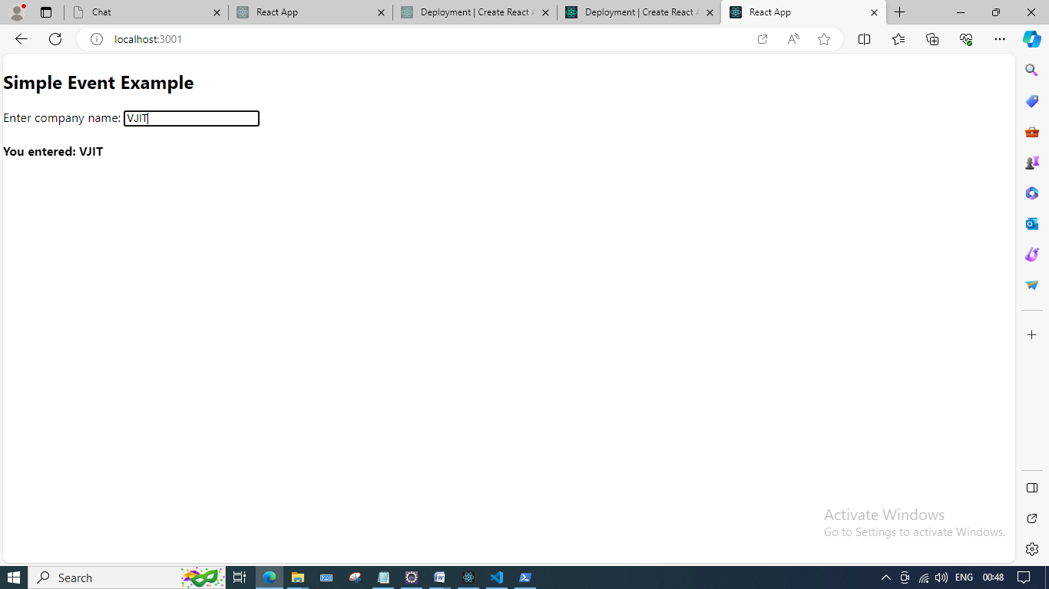

b)Write a program to create a simple voting application system using ReactJS
To create the example project for this voting, open command prompt, navigate to a convenient location, and run the command as shown below :
create-react-app voting
Now just replace the placeholder content of App.js and App.css with given below content :

src\App.js
import React,{Component} from 'react';
import './App.css';

class App extends Component{
constructor(props){
super(props);
this.state = {
languages : [
{name: "Php", votes: 0},
{name: "Python", votes: 0},
{name: "Go", votes: 0},
{name: "Java", votes: 0}
]
}
}

vote (i) {
let newLanguages = [...this.state.languages];
newLanguages[i].votes++;
function swap(array, i, j) {
var temp = array[i];
array[i] = array[j];
array[j] = temp;
}
this.setState({languages: newLanguages});

}

render(){
return(
<>
<h1>Vote Your Language!</h1>
<div className="languages">
{
this.state.languages.map((lang, i) =>
<div key={i} className="language">
<div className="voteCount">
{lang.votes}
</div>
<div className="languageName">
{lang.name}
</div>
<button onClick={this.vote.bind(this, i)}>Click Here</button>
</div>
)
}
</div>
</>
);
}
}
export default App;
In React we need to create a constructor function for our classes that extend React classes. We are passing an argument into super(props) called "props" this will also be available in the Component constructor class. The super() function will make this available in the constructor method.

src\App.css
*{
margin: 0;
padding: 0;
}

body {
text-align: center;
color: #222;
font-size: 24px;
font-family: sans-serif;
}

h1 {
margin: 30px;
}

.languages {
height: 400px;
width: 400px;
margin: 10px auto;
display: flex;
flex-direction: column;
}

.language {
flex: 1;
display: flex;
justify-content: space-between;
align-items: center;
padding: 10px 40px;
background-color: blanchedalmond;
border: 1px solid #222;
margin: 2px;
}

.voteCount {
border-radius: 50%;
display: flex;
justify-content: center;
align-items: center;
}

.language button {
color: green;
background-color: #0000;
border: none;
font-size: 30px;
outline: none;
cursor: pointer;
}
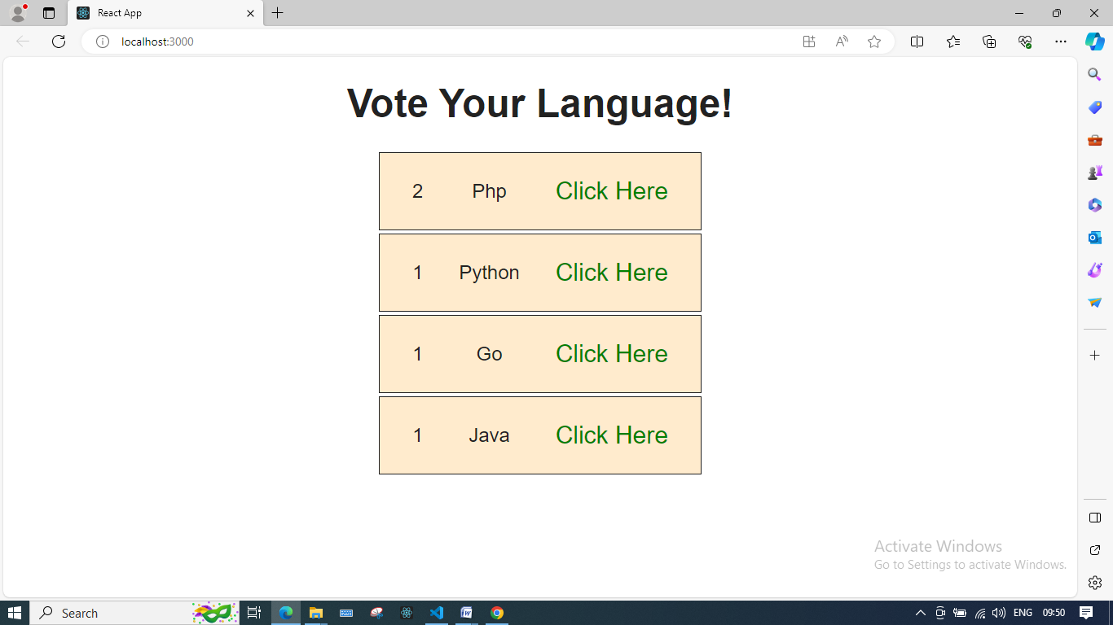

WEEK-7
Create a webpage to display “Hello World” using SERVLET.

public class HelloWorld extends HttpServlet {

private String message;

public void init() throws ServletException {
// Do required initialization
message = "Hello World";
}

public void doGet(HttpServletRequest request, HttpServletResponse response)
throws ServletException, IOException {

// Set response content type
response.setContentType("text/html");

// Actual logic goes here.
PrintWriter out = response.getWriter();
out.println("<h1>" + message + "</h1>");
}

public void destroy() {
// do nothing.
}
}

b) Implement a web application using SERVLET, which takes a name as input and on submitting it, shows a hello <name> page. It shows start time at the right top comer of the page and provides a logout button. On clicking logout button, it should show a logout page with Thank You <name> message with the duration of usage (hint: Use session to store name and time).
Session Time Out Example
You can set the session time out in two ways either in web.xml file or in servlet.
You can set session time out in web.xml as
<session-config>
<session-timeout>30</session-timeout>
</session-config>
Here 30 minutes is the maximum time out.
To set session time out in servlet you need to call session.getMaxInactiveInterval(300). Here 300 second is the time out .
An example is given below which illustrates the above concepts.
login.html
<HTML>
<HEAD>
<TITLE> Login Page </TITLE>
</HEAD>
<BODY>
<BODY bgcolor=lightblue>
<form name=login method="get"
action="http://localhost:8080/sessiontimeout/timeout">
<center>
<h1>Enter your Name and Pasword </h1><br>
<table border=1>
<tr><td>Enter Your Name :</td>
<td><input type="text" name="userName" value=""></td>
<tr><td align=center><input type="submit" name="Submit" value="Submit" ></td>
<td align=center><input type="reset" name="reset" value="Refresh"></td>
<table>
</center>
</form>
</BODY>
</HTML>
SessionTimeout.java
package roseindia.net;
import java.io.IOException;
import java.io.PrintWriter;
import javax.servlet.ServletException;
import javax.servlet.http.HttpServlet;
import javax.servlet.http.HttpServletRequest;
import javax.servlet.http.HttpServletResponse;
import javax.servlet.http.HttpSession;
public class SessionTimeout extends HttpServlet {
public void doGet(HttpServletRequest request, HttpServletResponse response)
throws IOException, ServletException {
PrintWriter out = response.getWriter();
response.setContentType("text/html");
String name = request.getParameter("userName");
if (name.equalsIgnoreCase("web")) {
out.println("<Center><h3>");
out.println("Creating A New Session...........");
out.println("</h3></Center>");
HttpSession session = request.getSession(true);
//Setting Session Inactive Time Out
session.setMaxInactiveInterval(20);
session.setAttribute("loggedUser", name);
out.println("<Center><h3>");
out.println("Session Created");
out.println("<br>Session Id - ");
out.println(session.getId());
out.println("<a href=\"http://localhost:8080/sessiontimeout/check\">Check Time Out</a>");
out.println("</h3></Center>");
} else {
out.println("<h1>");
out.println("Please enter the name \"web\"");
out.println("<h1>");
}
}
public void doPost(HttpServletRequest request, HttpServletResponse response)
throws IOException, ServletException {
doGet(request, response);
}
}
TimeoutCheck.java
package roseindia.net;
import java.io.IOException;
import java.io.PrintWriter;
import javax.servlet.ServletException;
import javax.servlet.http.HttpServlet;
import javax.servlet.http.HttpServletRequest;
import javax.servlet.http.HttpServletResponse;
import javax.servlet.http.HttpSession;
public class TimeoutCheck extends HttpServlet {
public void doGet(HttpServletRequest request, HttpServletResponse response)
throws IOException, ServletException {
PrintWriter out = response.getWriter();
response.setContentType("text/html");
String name = null;
HttpSession session = request.getSession(false);
if (session != null) {
name = (String) session.getAttribute("loggedUser");
out.println("<center><h1>");
out.println("Logged User is - ");
out.println(name);
out.println("</h1></center>");
} else {
out.println("<center><h1>");
out.println("Session Session Time Out");
out.println("</h1></center>");
}
}
public void doPost(HttpServletRequest request, HttpServletResponse response)
throws IOException, ServletException {
}
}
web.xml
<?xml version="1.0" encoding="UTF-8"?>
<web-app id="WebApp_ID" version="2.4" xmlns="http://java.sun.com/xml/ns/j2ee" xmlns:xsi="http://www.w3.org/2001/XMLSchema-instance" xsi:schemaLocation="http://java.sun.com/xml/ns/j2ee http://java.sun.com/xml/ns/j2ee/web-app_2_4.xsd">
<display-name>CreateSession</display-name>
<!-- Servlet -->
<servlet>
<servlet-name>SessionTimeout</servlet-name>
<servlet-class>roseindia.net.SessionTimeout</servlet-class>
</servlet>
<servlet>
<servlet-name>TimeoutCheck</servlet-name>
<servlet-class>roseindia.net.TimeoutCheck</servlet-class>
</servlet>
<!-- Servlet Mapping-->
<servlet-mapping>
<servlet-name>SessionTimeout</servlet-name>
<url-pattern>/timeout</url-pattern>
</servlet-mapping>
<servlet-mapping>
<servlet-name>TimeoutCheck</servlet-name>
<url-pattern>/check</url-pattern>
</servlet-mapping>
<!-- Setting Session Time Out-->
<session-config>
<session-timeout>2</session-timeout>
</session-config>
</web-app>
When you run this application it will display message as shown below:
After 20 Seconds

WEEK-8
Write a JSP program to find a factorial of the given number.
<%@ page language="java" contentType="text/html; charset=ISO-8859-1"
pageEncoding="ISO-8859-1"%>
<!DOCTYPE html PUBLIC "-//W3C//DTD HTML 4.01 Transitional//EN" "http://www.w3.org/TR/html4/loose.dtd">
<html>
<head>
<meta http-equiv="Content-Type" content="text/html; charset=ISO-8859-1">
<title>Factorial of a Number</title>
</head>
<body>
<form name="f1" method="post" action="Factorial.jsp">
Enter a Number: <input type="text" name="n"/>
<br/>
<input type ="submit" value="Find Factorial"/>
</form>

<%!
int find_factorial(int n)
{
if(n==0)
return 1;
return n*find_factorial(n-1);
}
%>
<%
String inp=request.getParameter("n");
if(inp!=null)
{
int px=Integer.parseInt(inp);
int fact=find_factorial(px);
out.println("<br/>Factorial = " + fact);
}
%>
</body>
</html>

- B) Create a user validation web application using JSP, where the user submits the login name and password to the server. The name and password are checked against the data already available in database and if the data matches, a successfull login page is returned. Otherwise show a failure message to the user.

MySQL Database Setup

Let's create a database named "mysql_database" in MySQL. Now, create a login table using below DDL script:

CREATE TABLE `login` (

`username` varchar(45) NOT NULL,

`password` varchar(45) DEFAULT NULL,

PRIMARY KEY (`username`)

) ENGINE=InnoDB DEFAULT CHARSET=utf8mb4 COLLATE=utf8mb4_0900_ai_ci;

Here is an Insert SQL statement:

INSERT INTO `mysql`.`login` (`username`, `password`) VALUES ("Ramesh", "Ramesh");
Input1.jsp
<%@ page language="java" contentType="text/html; charset=UTF-8"
pageEncoding="UTF-8"%>
<!doctype html>
<html lang="en">
<head>
<title>Welcome </title>
</head>
<body>
<form method = "post" action = "JspDB1.jsp">
<fieldset style="width:23%; background-color:#b3d1ff">
<h3><center> Login Page</center></h3>
<hr>
<table>
<tr>
<td>Username:</td>
<td> <input type = "text" name = "uname"></td>
</tr>
<tr>
<td>Password:</td>
<td><input type = "password" name = "pwd"></td>
</tr>
<tr>
<td></td>
<td><input type = "submit" value="check detail" name = "s1"></td>
</tr>
</table>
</fieldset>
</form>
<!-- <a href="JspDB.jsp? s1=link">Get all user detail</a> -->
</body>
</html>
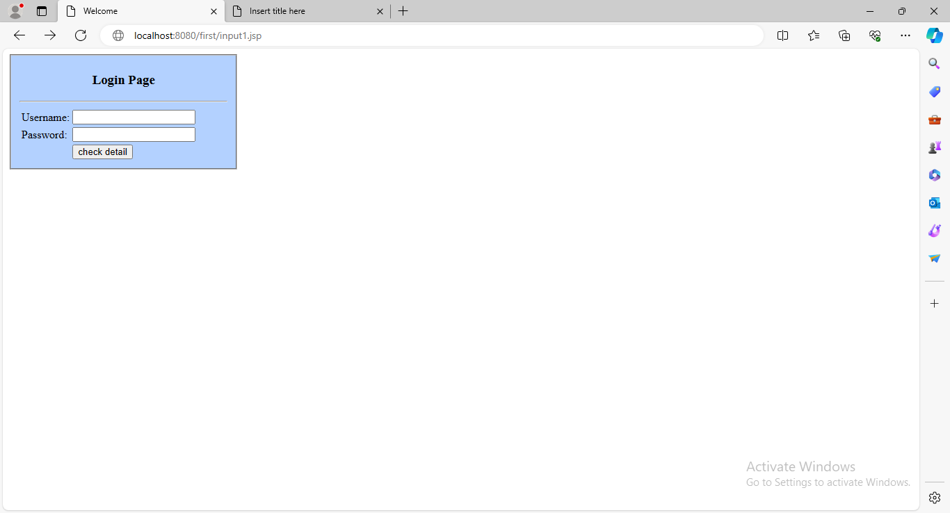
JspDB.jsp
<%@ page language="java" contentType="text/html; charset=UTF-8"
pageEncoding="UTF-8"%>
<%@ page import="java.sql.*"%>
<%@ page import="java.util.*"%>
<!DOCTYPE html>
<html>
<head>
<meta charset="UTF-8">
<title>Insert title here</title>
</head>
<body>
<%
String un=request.getParameter("uname");
String pwd=request.getParameter("pwd");
try
{
Class.forName("com.mysql.jdbc.Driver");
Connection connection=DriverManager.getConnection("jdbc:mysql://localhost:3306/mysql","root","root");
Statement statement=connection.createStatement();
ResultSet set=statement.executeQuery("select * from login");
int flag=0;
while(set.next())
{
if(un.equals(set.getString(1)) && pwd.equals(set.getString(2)))
{
flag=1;
}
}
if(flag==1)
{
response.sendRedirect("welcome.jsp");
}
else
{
response.sendRedirect("Not.jsp");
}
out.println("Connected");
}
catch(Exception e)
{
System.out.println(e);
}
%>
</body>
</html>
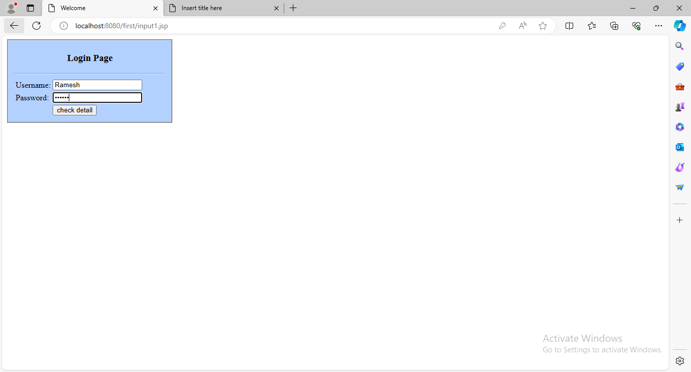
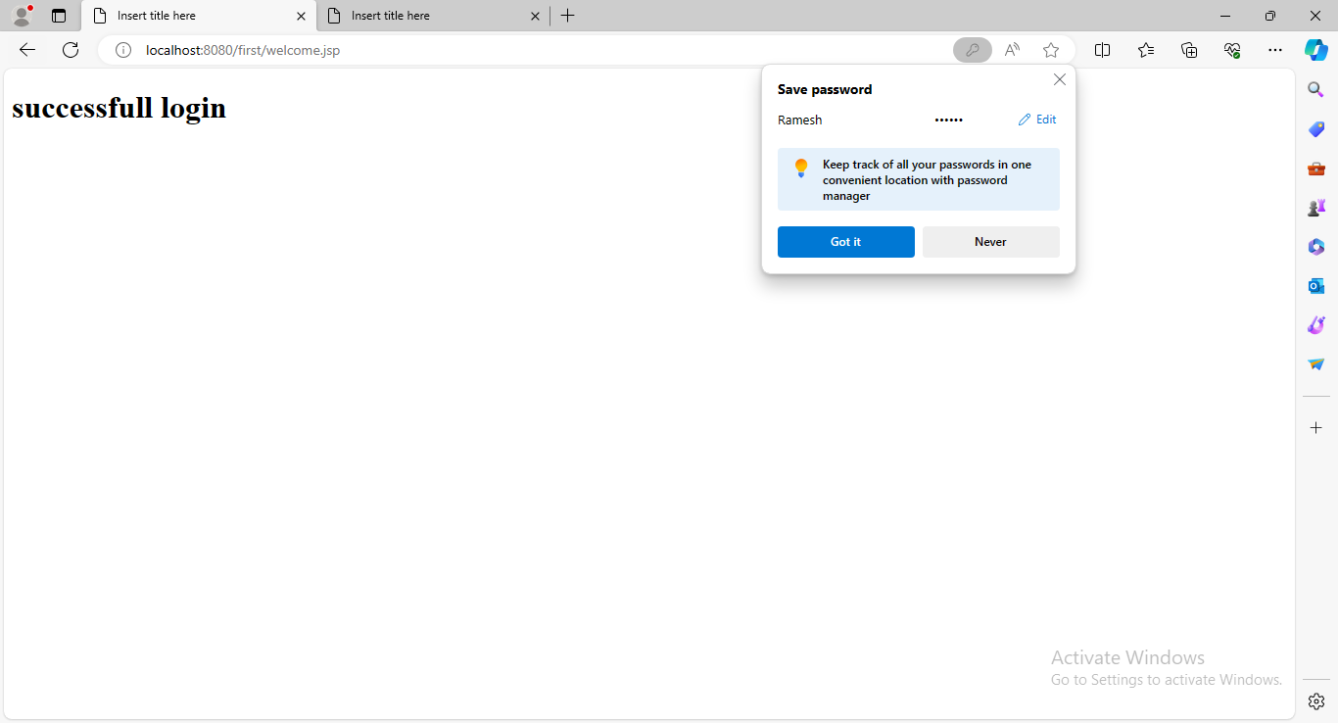
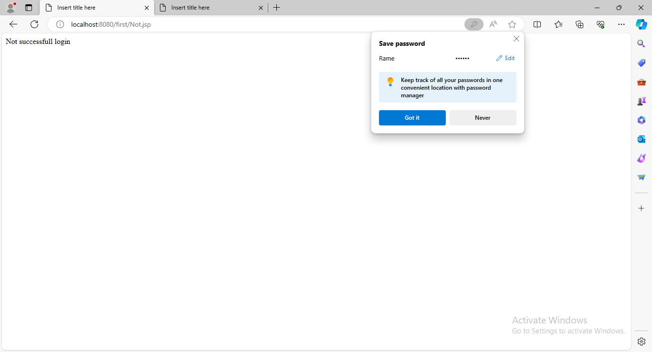
WEEK-9
9. a) Demonstrate a simple example of Spring web MVC framework.

Spring Web MVC Framework Example

Let's see the simple example of a Spring Web MVC framework. The steps are as follows:
- Load the spring jar files or add dependencies in the case of Maven
- Create the controller class
- Provide the entry of controller in the web.xml file
- Define the bean in the separate XML file
- Display the message in the JSP page
- Start the server and deploy the project

Directory Structure of Spring MVC

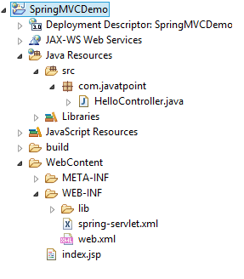

Directory Structure of Spring MVC using Maven

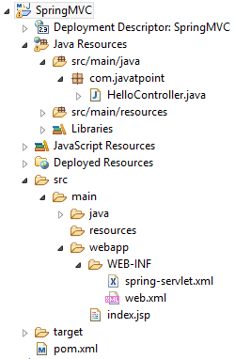

- Load the spring jar files or add dependencies in the case of Maven
- Create the controller class
- Provide the entry of controller in the web.xml file
- Define the bean in the separate XML file
- Display the message in the JSP page
- Start the server and deploy the project

Directory Structure of Spring MVC

Directory Structure of Spring MVC using Maven

Required Jar files or Maven Dependency

To run this example, you need to load:
- Spring Core jar files
- Spring Web jar files
- JSP + JSTL jar files (If you are using any another view technology then load the corresponding jar files).

Download Link: Download all the jar files for spring including JSP and JSTL.

If you are using Maven, you don't need to add jar files. Now, you need to add maven dependency to the pom.xml file.

1. Provide project information and configuration in the pom.xml file.

pom.xml
- <project xmlns="http://maven.apache.org/POM/4.0.0" xmlns:xsi="http://www.w3.org/2001/XMLSchema-instance"
- xsi:schemaLocation="http://maven.apache.org/POM/4.0.0 http://maven.apache.org/maven-v4_0_0.xsd">
- <modelVersion>4.0.0</modelVersion>
- <groupId>com.javatpoint</groupId>
- <artifactId>SpringMVC</artifactId>
- <packaging>war</packaging>
- <version>0.0.1-SNAPSHOT</version>
- <name>SpringMVC Maven Webapp</name>
- <url>http://maven.apache.org</url>
- <dependencies>
- <dependency>
- <groupId>junit</groupId>
- <artifactId>junit</artifactId>
- <version>3.8.1</version>
- <scope>test</scope>
- </dependency>

- <!-- https://mvnrepository.com/artifact/org.springframework/spring-webmvc -->
- <dependency>
- <groupId>org.springframework</groupId>
- <artifactId>spring-webmvc</artifactId>
- <version>5.1.1.RELEASE</version>
- </dependency>

- <!-- https://mvnrepository.com/artifact/javax.servlet/javax.servlet-api -->
- <dependency>
- <groupId>javax.servlet</groupId>
- <artifactId>servlet-api</artifactId>
- <version>3.0-alpha-1</version>
- </dependency>

- </dependencies>
- <build>
- <finalName>SpringMVC</finalName>
- </build>
- </project>

2. Create the controller class

To create the controller class, we are using two annotations @Controller and @RequestMapping.

The @Controller annotation marks this class as Controller.

The @Requestmapping annotation is used to map the class with the specified URL name.

HelloController.java
- package com.javatpoint;
- import org.springframework.stereotype.Controller;
- import org.springframework.web.bind.annotation.RequestMapping;
- @Controller
- public class HelloController {
- @RequestMapping("/")
- public String display()
- {
- return "index";
- }
- }

3. Provide the entry of controller in the web.xml file

In this xml file, we are specifying the servlet class DispatcherServlet that acts as the front controller in Spring Web MVC. All the incoming request for the html file will be forwarded to the DispatcherServlet.

web.xml
- <?xml version="1.0" encoding="UTF-8"?>
- <web-app xmlns:xsi="http://www.w3.org/2001/XMLSchema-instance" xmlns="http://java.sun.com/xml/ns/javaee" xsi:schemaLocation="http://java.sun.com/xml/ns/javaee http://java.sun.com/xml/ns/javaee/web-app_3_0.xsd" id="WebApp_ID" version="3.0">
- <display-name>SpringMVC</display-name>
- <servlet>
- <servlet-name>spring</servlet-name>
- <servlet-class>org.springframework.web.servlet.DispatcherServlet</servlet-class>
- <load-on-startup>1</load-on-startup>
- </servlet>
- <servlet-mapping>
- <servlet-name>spring</servlet-name>
- <url-pattern>/</url-pattern>
- </servlet-mapping>
- </web-app>

4. Define the bean in the xml file

This is the important configuration file where we need to specify the View components.

The context:component-scan element defines the base-package where DispatcherServlet will search the controller class.

This xm spring-servlet.xml
- <?xml version="1.0" encoding="UTF-8"?>
- <beans xmlns="http://www.springframework.org/schema/beans"
- xmlns:xsi="http://www.w3.org/2001/XMLSchema-instance"
- xmlns:context="http://www.springframework.org/schema/context"
- xmlns:mvc="http://www.springframework.org/schema/mvc"
- xsi:schemaLocation="
- http://www.springframework.org/schema/beans
- http://www.springframework.org/schema/beans/spring-beans.xsd
- http://www.springframework.org/schema/context
- http://www.springframework.org/schema/context/spring-context.xsd
- http://www.springframework.org/schema/mvc
- http://www.springframework.org/schema/mvc/spring-mvc.xsd">

- <!-- Provide support for component scanning -->
- <context:component-scan base-package="com.javatpoint" />

- <!--Provide support for conversion, formatting and validation -->
- <mvc:annotation-driven/>

- </beans>

5. Display the message in the JSP page

This is the simple JSP page, displaying the message returned by the Controller.

index.jsp
- <html>
- <body>
- <p>Welcome to Spring MVC Tutorial</p>
- </body>
- </html>

l file should be located inside the WEB-INF directory.

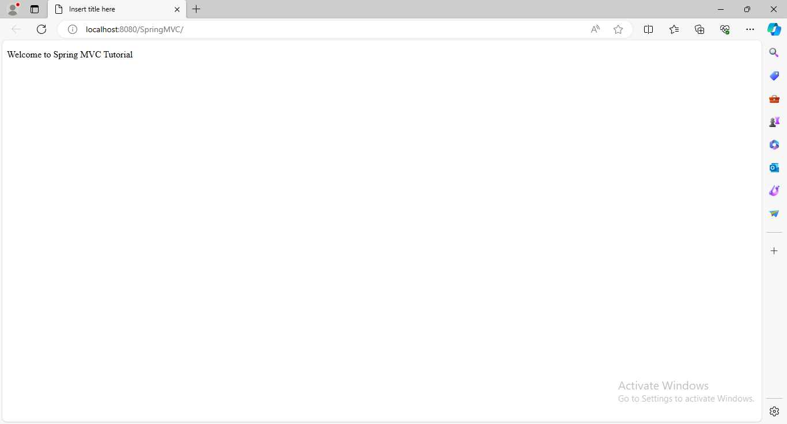
b) Illustrate how database is connected in Spring Framework by using simple CRUD application.

WEEK-10
10. a) create a simple example of hibernate application using eclipse IDE.
b) Create an application to demonstrate Hibernate Query Language.

WEEK-11 and 12
CASE STUDY-1: Create a Chat module/Interface using HTML CSS and JavaScript. The chat interface primarily consists of two segments: the message header and the chat box.
Message-Header- The message header resides at the top of the chat box. It includes the user's name, avatar or profile image, and the user's last seen. Last seen is the last time the user was active.
The Chat-Box- The chat box consists of the message page and the message bottom sections.
• Message page-The message page consists of incoming and outgoing messages, as well as the avatars of the senders. It also displays the time at which each message is sent.
• The Message-Bottom-This section contains an input field where the user can type in the messages and a send button to send them.

Index.html
<!DOCTYPE html>
<html>
<head>
<title>Chat</title>
<!-- Bootstrap -->
<link rel="stylesheet" href="https://stackpath.bootstrapcdn.com/bootstrap/4.1.3/css/bootstrap.min.css" >
<!-- Font awesome -->
<link rel="stylesheet" href="https://use.fontawesome.com/releases/v5.5.0/css/all.css" >
<!-- CSS -->
<link rel="stylesheet" type="text/css" href="style.css">
</head>
<body>
<div class="container-fluid h-100">
<div class="row justify-content-center h-100">
<div class="col-md-4 col-xl-3 chat"><div class="card mb-sm-3 mb-md-0 contacts_card">
<div class="card-header">
<div class="input-group">
<input type="text" placeholder="Search..." name="" class="form-control search">
<div class="input-group-prepend">
<span class="input-group-text search_btn"><i class="fas fa-search"></i></span>
</div>
</div>
</div>
<div class="card-body contacts_body">
<ui class="contacts">
<li class="active">
<div class="d-flex bd-highlight">
<div class="img_cont">
<img src="https://static.turbosquid.com/Preview/001292/481/WV/_D.jpg" class="rounded-circle user_img">
<span class="online_icon"></span>
</div>
<div class="user_info">
<span>Khalid Charif</span>
<p>Online</p>
</div>
</div>
</li>
<li>
<div class="d-flex bd-highlight">
<div class="img_cont">
<img src="https://2.bp.blogspot.com/-8ytYF7cfPkQ/WkPe1-rtrcI/AAAAAAAAGqU/FGfTDVgkcIwmOTtjLka51vineFBExJuSACLcBGAs/s320/31.jpg" class="rounded-circle user_img">
<span class="online_icon offline"></span>
</div>
<div class="user_info">
<span>Chaymae Naim</span>
<p>Left 7 mins ago</p>
</div>
</div>
</li>
<li>
<div class="d-flex bd-highlight">
<div class="img_cont">
<img src="https://i.pinimg.com/originals/ac/b9/90/acb990190ca1ddbb9b20db303375bb58.jpg" class="rounded-circle user_img">
<span class="online_icon"></span>
</div>
<div class="user_info">
<span>Sami Rafi</span>
<p>Online</p>
</div>
</div>
</li>
<li>
<div class="d-flex bd-highlight">
<div class="img_cont">
<img src="https://avatars.hsoubcdn.com/ed57f9e6329993084a436b89498b6088?s=256" class="rounded-circle user_img">
<span class="online_icon offline"></span>
</div>
<div class="user_info">
<span>Hassan Agmir</span>
<p>Left 30 mins ago</p>
</div>
</div>
</li>
<li>
<div class="d-flex bd-highlight">
<div class="img_cont">
<img src="https://static.turbosquid.com/Preview/001214/650/2V/boy-cartoon-3D-model_D.jpg" class="rounded-circle user_img">
<span class="online_icon offline"></span>
</div>
<div class="user_info">
<span>Abdou Chatabi</span>
<p>Left 50 mins ago</p>
</div>
</div>
</li>
</ui>
</div>
<div class="card-footer"></div>
</div></div>
<div class="col-md-8 col-xl-6 chat">
<div class="card">
<div class="card-header msg_head">
<div class="d-flex bd-highlight">
<div class="img_cont">
<img src="https://static.turbosquid.com/Preview/001292/481/WV/_D.jpg" class="rounded-circle user_img">
<span class="online_icon"></span>
</div>
<div class="user_info">
<span>khalid Charif</span>
<p>1767 Messages</p>
</div>
<div class="video_cam">
<span><i class="fas fa-video"></i></span>
<span><i class="fas fa-phone"></i></span>
</div>
</div>
<span id="action_menu_btn"><i class="fas fa-ellipsis-v"></i></span>
<div class="action_menu">
<ul>
<li><i class="fas fa-user-circle"></i> View profile</li>
<li><i class="fas fa-users"></i> Add to close friends</li>
<li><i class="fas fa-plus"></i> Add to group</li>
<li><i class="fas fa-ban"></i> Block</li>
</ul>
</div>
</div>
<div class="card-body msg_card_body">
<div class="d-flex justify-content-start mb-4">
<div class="img_cont_msg">
<img src="https://static.turbosquid.com/Preview/001292/481/WV/_D.jpg" class="rounded-circle user_img_msg">
</div>
<div class="msg_cotainer">
Hi, how are you samim?
<span class="msg_time">8:40 AM, Today</span>
</div>
</div>
<div class="d-flex justify-content-end mb-4">
<div class="msg_cotainer_send">
Hi Khalid i am good tnx how about you?
<span class="msg_time_send">8:55 AM, Today</span>
</div>
<div class="img_cont_msg">
<img src="https://avatars.hsoubcdn.com/ed57f9e6329993084a436b89498b6088?s=256" class="rounded-circle user_img_msg">
</div>
</div>
<div class="d-flex justify-content-start mb-4">
<div class="img_cont_msg">
<img src="https://static.turbosquid.com/Preview/001292/481/WV/_D.jpg" class="rounded-circle user_img_msg">
</div>
<div class="msg_cotainer">
I am good too, thank you for your chat template
<span class="msg_time">9:00 AM, Today</span>
</div>
</div>
<div class="d-flex justify-content-end mb-4">
<div class="msg_cotainer_send">
You are welcome
<span class="msg_time_send">9:05 AM, Today</span>
</div>
<div class="img_cont_msg">
<img src="https://avatars.hsoubcdn.com/ed57f9e6329993084a436b89498b6088?s=256" class="rounded-circle user_img_msg">
</div>
</div>
<div class="d-flex justify-content-start mb-4">
<div class="img_cont_msg">
<img src="https://static.turbosquid.com/Preview/001292/481/WV/_D.jpg" class="rounded-circle user_img_msg">
</div>
<div class="msg_cotainer">
I am looking for your next templates
<span class="msg_time">9:07 AM, Today</span>
</div>
</div>
<div class="d-flex justify-content-end mb-4">
<div class="msg_cotainer_send">
Ok, thank you have a good day
<span class="msg_time_send">9:10 AM, Today</span>
</div>
<div class="img_cont_msg">
<img src="https://avatars.hsoubcdn.com/ed57f9e6329993084a436b89498b6088?s=256" class="rounded-circle user_img_msg">
</div>
</div>
<div class="d-flex justify-content-start mb-4">
<div class="img_cont_msg">
<img src="https://static.turbosquid.com/Preview/001292/481/WV/_D.jpg" class="rounded-circle user_img_msg">
</div>
<div class="msg_cotainer">
Bye, see you
<span class="msg_time">9:12 AM, Today</span>
</div>
</div>
</div>
<div class="card-footer">
<div class="input-group">
<div class="input-group-append">
<span class="input-group-text attach_btn"><i class="fas fa-paperclip"></i></span>
</div>
<textarea name="" class="form-control type_msg" placeholder="Type your message..."></textarea>
<div class="input-group-append">
<span class="input-group-text send_btn"><i class="fas fa-location-arrow"></i></span>
</div>
</div>
</div>
</div>
</div>
</div>
</div>
<!-- JQuery -->
<script src="https://ajax.googleapis.com/ajax/libs/jquery/3.3.1/jquery.min.js"></script>
<script type="text/javascript" src="scripts.js"></script>
</body>
</html>

Scripts.js

$(document).ready(function(){
$('#action_menu_btn').click(function(){
$('.action_menu').toggle();
});
});

Style.css
body,
html {
height: 100%;
margin: 0;
background: #7F7FD5;
background: -webkit-linear-gradient(to right, #91EAE4, #86A8E7, #7F7FD5);
background: linear-gradient(to right, #91EAE4, #86A8E7, #7F7FD5);
}

.chat {
margin-top: auto;
margin-bottom: auto;
}

.card {
height: 500px;
border-radius: 15px !important;
background-color: rgba(0, 0, 0, 0.4) !important;
}

.contacts_body {
padding: 0.75rem 0 !important;
overflow-y: auto;
white-space: nowrap;
}

.msg_card_body {
overflow-y: auto;
}

.card-header {
border-radius: 15px 15px 0 0 !important;
border-bottom: 0 !important;
}

.card-footer {
border-radius: 0 0 15px 15px !important;
border-top: 0 !important;
}

.container {
align-content: center;
}

.search {
border-radius: 15px 0 0 15px !important;
background-color: rgba(0, 0, 0, 0.3) !important;
border: 0 !important;
color: white !important;
}

.search:focus {
box-shadow: none !important;
outline: 0px !important;
}

.type_msg {
background-color: rgba(0, 0, 0, 0.3) !important;
border: 0 !important;
color: white !important;
height: 60px !important;
overflow-y: auto;
}

.type_msg:focus {
box-shadow: none !important;
outline: 0px !important;
}

.attach_btn {
border-radius: 15px 0 0 15px !important;
background-color: rgba(0, 0, 0, 0.3) !important;
border: 0 !important;
color: white !important;
cursor: pointer;
}

.send_btn {
border-radius: 0 15px 15px 0 !important;
background-color: rgba(0, 0, 0, 0.3) !important;
border: 0 !important;
color: white !important;
cursor: pointer;
}

.search_btn {
border-radius: 0 15px 15px 0 !important;
background-color: rgba(0, 0, 0, 0.3) !important;
border: 0 !important;
color: white !important;
cursor: pointer;
}

.contacts {
list-style: none;
padding: 0;
}

.contacts li {
width: 100% !important;
padding: 5px 10px;
margin-bottom: 15px !important;
}

.active {
background-color: rgba(0, 0, 0, 0.3);
}

.user_img {
height: 60px;
width: 60px;
border: 1.5px solid #f5f6fa;
}

.user_img_msg {
height: 40px;
width: 40px;
border: 1.5px solid #f5f6fa;
}

.img_cont {
position: relative;
height: 70px;
width: 70px;
}

.img_cont_msg {
height: 40px;
width: 40px;
}

.online_icon {
position: absolute;
height: 15px;
width: 15px;
background-color: #4cd137;
border-radius: 50%;
bottom: 13px;
right: 13px;
border: 1.5px solid white;
}

.offline {
background-color: #c23616 !important;
}

.user_info {
margin-top: auto;
margin-bottom: auto;
margin-left: 15px;
}

.user_info span {
font-size: 20px;
color: white;
}

.user_info p {
font-size: 10px;
color: rgba(255, 255, 255, 0.6);
}

.video_cam {
margin-left: 50px;
margin-top: 5px;
}

.video_cam span {
color: white;
font-size: 20px;
cursor: pointer;
margin-right: 20px;
}

.msg_cotainer {
margin-top: auto;
margin-bottom: auto;
margin-left: 10px;
border-radius: 25px;
background-color: #82ccdd;
padding: 10px;
position: relative;
}

.msg_cotainer_send {
margin-top: auto;
margin-bottom: auto;
margin-right: 10px;
border-radius: 25px;
background-color: #78e08f;
padding: 10px;
position: relative;
}

.msg_time {
position: absolute;
left: 0;
bottom: -15px;
color: rgba(255, 255, 255, 0.5);
font-size: 10px;
}

.msg_time_send {
position: absolute;
right: 0;
bottom: -15px;
color: rgba(255, 255, 255, 0.5);
font-size: 10px;
}

.msg_head {
position: relative;
}

#action_menu_btn {
position: absolute;
right: 10px;
top: 10px;
color: white;
cursor: pointer;
font-size: 20px;
}

.action_menu {
z-index: 1;
position: absolute;
padding: 15px 0;
background-color: rgba(0, 0, 0, 0.5);
color: white;
border-radius: 15px;
top: 30px;
right: 15px;
display: none;
}

.action_menu ul {
list-style: none;
padding: 0;
margin: 0;
}

.action_menu ul li {
width: 100%;
padding: 10px 15px;
margin-bottom: 5px;
}

.action_menu ul li i {
padding-right: 10px;
}

.action_menu ul li:hover {
cursor: pointer;
background-color: rgba(0, 0, 0, 0.2);
}

/* width */

::-webkit-scrollbar {
width: 10px;
}

/* Track */

::-webkit-scrollbar-track {
background: #f1f1f1;
}

/* Handle */

::-webkit-scrollbar-thumb {
background: #888;
}

/* Handle on hover */

::-webkit-scrollbar-thumb:hover {
background: #555;
}

@media(max-width: 576px) {
.contacts_card {
margin-bottom: 15px !important;
}
}

